

|  |
| --- |
| TEAM 1 REPORT |
|  |
| November 11  Aye Moe Phyu - e0457825  Kaung Khant Kyaw - e0457836  Ngik Guo Ming - e0457839  Suwetaa Ramesh - e0457811  Tang Qianwenjing - e0457780  Wang Xuezhi - e0457838 |

Contents

Part 1: Supervised Machine Learning 4

a) Linear regression 4

Problem statement 4

Data dictionary 4

Source of dataset 4

Duration of training 4

Sharing of the process 6

b) Classification techniques 8

Problem statement 8

Data dictionary 9

Source of dataset 9

(1) Logistic regression 10

Duration of training 10

Sharing of the process 10

Impact of data engineering & feature engineering 13

Other observations 13

(2) K-NN classification 13

Duration of training 13

Sharing of the process 14

Impact of data engineering & feature engineering 20

Other observations 21

(3) Decision trees 21

Duration of training 21

Sharing of the process 21

Impact of data engineering & feature engineering 27

Other observations 27

Conclusion (model that yields the best outcome) 27

Part 2: Unsupervised Machine Learning 28

Problem statement 28

Data dictionary 28

Source of dataset 29

a) K-means (with & without PCA) 30

Duration of training 30

Sharing of the process 30

Impact of data engineering & feature engineering 36

Other observations 36

b) Agglomerative (Hierarchical) clustering (with & without PCA) 36

Duration of training 36

Sharing of the process 37

Impact of data engineering & feature engineering 44

Other observations 45

c) DBSCAN (with & without PCA) 48

Duration of training 48

Sharing of the process 48

Impact of data engineering & feature engineering 54

Other observations 54

Conclusion (model that yields the best outcome) 55

Part 3: Attempting Neural Network 55

Duration of training 55

Sharing of the process 55

Impact of data engineering & feature engineering 57

Other observations 57

Conclusion 58

# Part 1: Supervised Machine Learning

## a) Linear regression

### Problem statement

To build a linear regression model to be able to predict the average house price in the USA, based on income of the people, the age of the house, and number of rooms in a house, etc.

### Data dictionary

|  |  |  |
| --- | --- | --- |
| **Variable** | **Type** | **Definition** |
| Avg. Area Income | float64 | Average income (dollars) of the people within the area. |
| Avg. Area House Age | float64 | Average age (years) of the house within the area. |
| Avg. Area Number of Rooms | float64 | Average number of rooms per dwelling within the area. |
| Avg. Area Number of Bedrooms | float64 | Average number of bedrooms in a house within the area. |
| Area Population | float64 | Population (people) within the area. |
| Price (dependent variable) | float64 | Price (dollars) of a house. |

### Source of dataset

<https://www.kaggle.com/dmvreddy91/usahousing>

### Duration of training

First model:0.002994060516357422 seconds

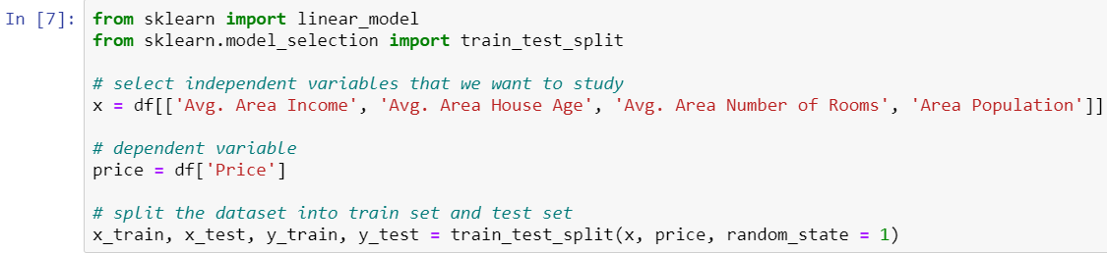

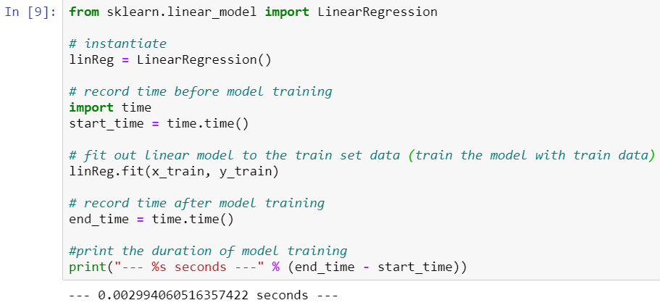

Second model:0.001994609832763672 seconds

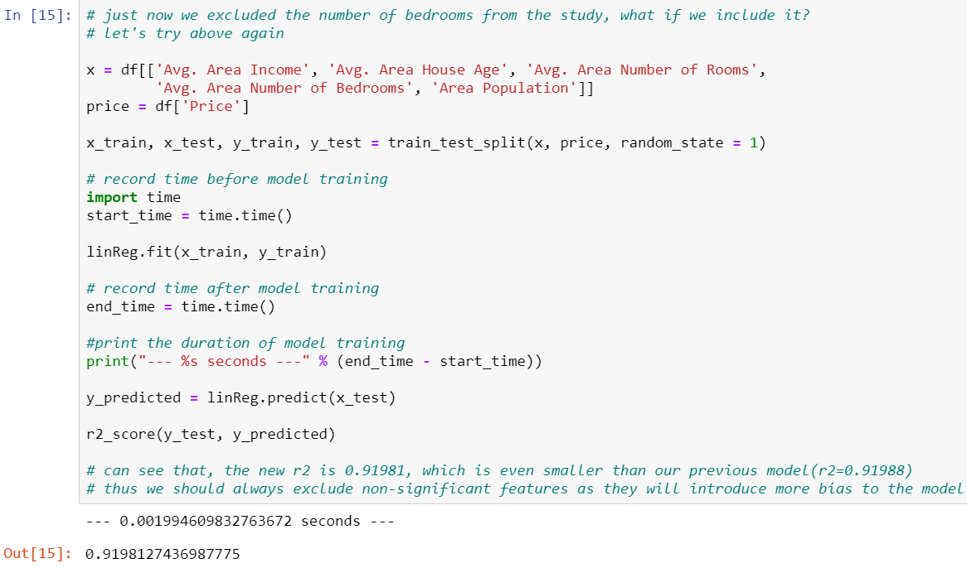

Initially in my perspective, increasing the number of features may lead to increase in training time. However, as shown in the records, there is no significant difference in training time between two models. In fact, the training duration for second model which contains more features is shorter than the first model.

In conclusion, more features do not necessarily lead to longer training time, also for linear regression, the performance is normally not an issue, even with hundreds of features. So, for our study, this duration difference is negligible.

### Sharing of the process

#### Understand data

By using “describe()” function, we have learned that this dataset has 5000 records and 7 columns, 6 of them are “float64” data type, and one is “object”. The data do not have any non-null value; thus, we do not need to perform data cleaning or data engineering for missing data on this dataset. For those datasets has significant number of null values, data engineering is necessary.







#### Visualization

Plot linear regression and find scatter plot between each variable helped us to figure out which variable is strongly correlated with the dependent variable. Through visualization, we can see that "Ave. Area Income", "Ave. Area House Age", "Ave. Area Number of Rooms", and "Area Population" showed strong correlation with "Price", bring good features for our model. For "Ave. Area Number of Bedrooms", there is a weak correlation, there we cannot conclude if including it as a feature will contribute to our model which we will figure it out in the later analysis.



#### First model

For the first model, we have selected "Ave. Area Income", "Ave. Area House Age", "Ave. Area Number of Rooms", and "Area Population" as independent variables. -“mean_squared_error” =10605006369.911247,

-“r2_score” = 0.9198837224059702.

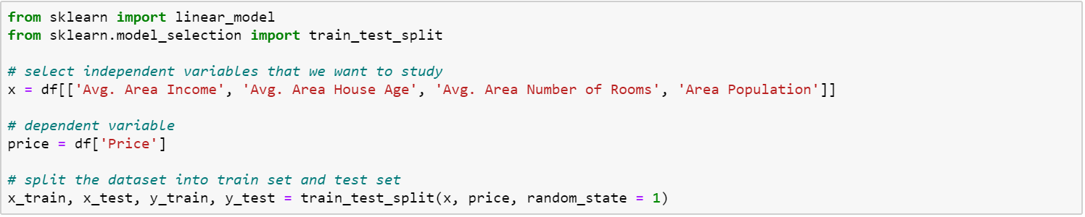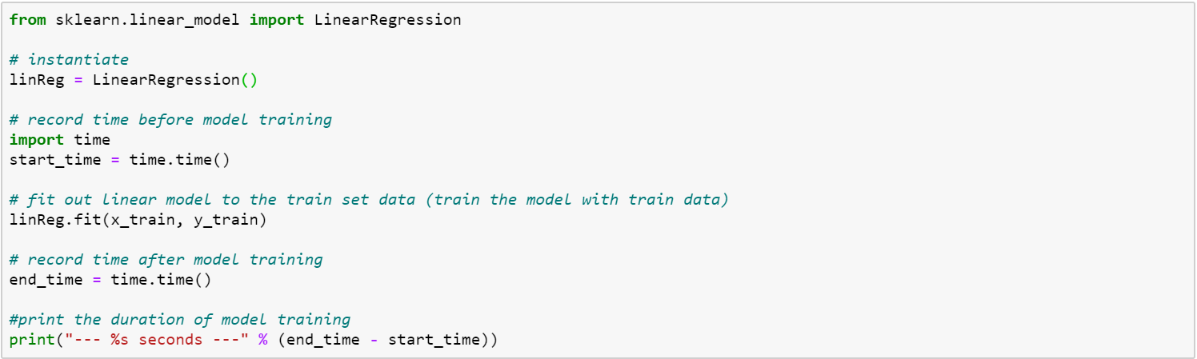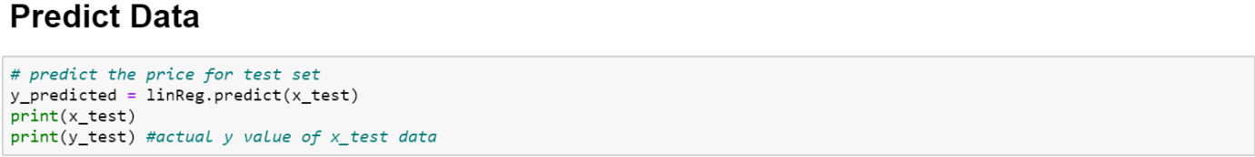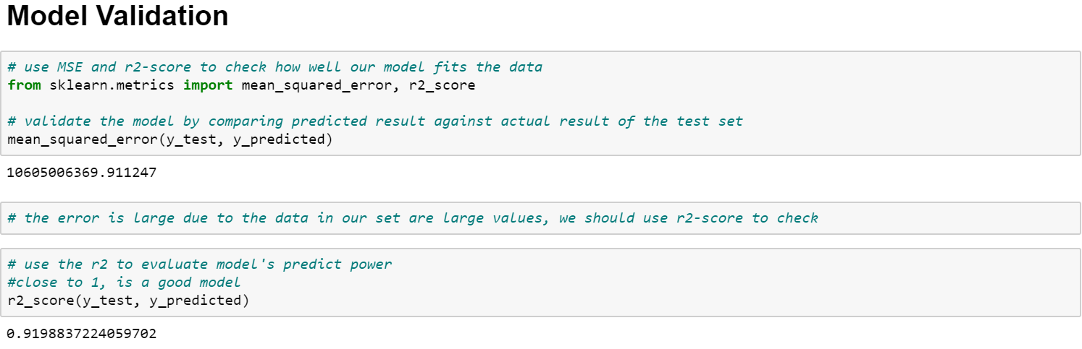

#### Second model

"Ave. Area Number of Bedrooms" is added into the set of features, in addition to the features used on the first model.

-“mean_squared_error” =10614401834.409979,

-“r2_score” = 0.9198127436987775.

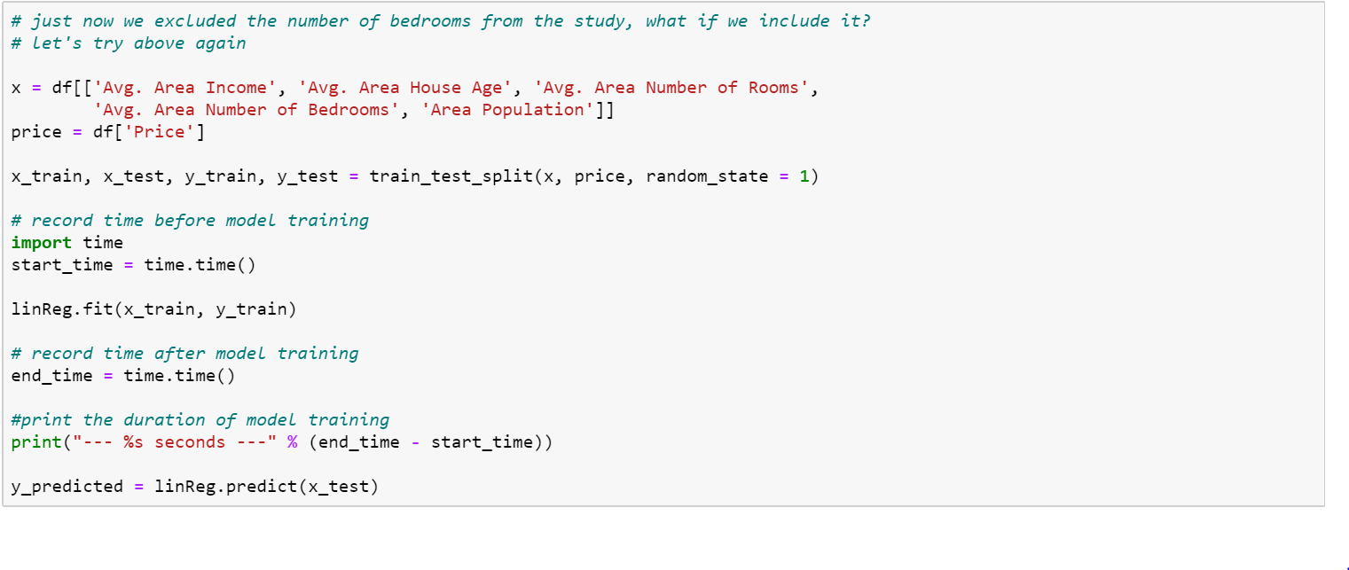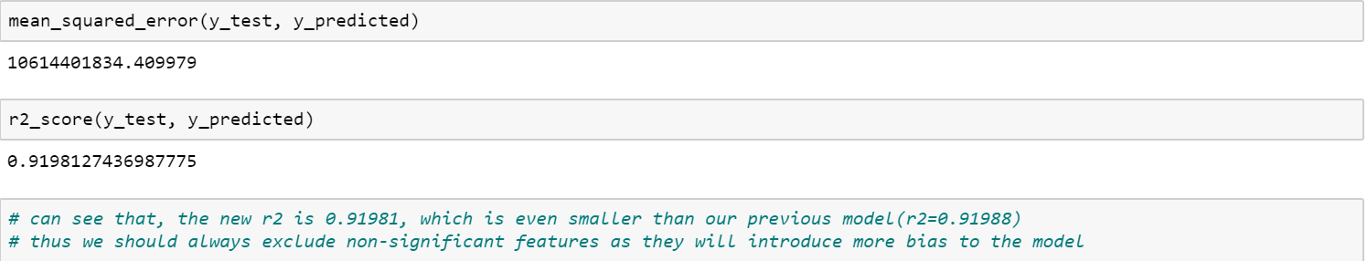

#### Impact of data engineering & feature engineering

The mean squared error is large due to the data in our set are large values, so we have chosen r2-score to evaluate our model. Although both models are good based on the r2-score, the first model has a higher score. We can see that "Ave. Area Number of Bedrooms" does not contribute to the model, and even made it worse. Thus, the first model is chosen to be presented.

#### Other observations

We should always exclude non-significant features, because instead of making a better model, they introduce more bias to the model. And more features do not necessarily lead to longer training time. For linear regression, the performance is usually not an issue, even with hundreds of features. So, for our study, this duration difference is negligible. The linear regression model able to predict the average house price in the USA, based on income of the people, the age of the house, and number of rooms in a house, and area population, with R square score = 0.92.

## b) Classification techniques

### Problem statement

We have a data set of different information about passengers onboard the Titanic, and we see if we can use that information to predict whether those people survived or not.

### Data dictionary

|  |  |  |
| --- | --- | --- |
| **Variable** | **Type** | **Definition** |
| PassengerId | int64 | Unique ID of the passenger |
| Survived | int64 | Survival of the passenger  0 = No, 1 = Yes |
| Pclass | int64 | Ticket class  1 = 1st class, 2 = 2nd class, 3 = 3rd class |
| Name | object | Passenger's name |
| Sex | object | Gender |
| Age | float64 | Age in years |
| SibSp | int64 | Number of siblings / spouses aboard the Titanic |
| Parch | int64 | Number of parents / children aboard the Titanic |
| Ticket | object | Ticket number |
| Fare | float64 | Fare paid for ticket |
| Cabin | object | Cabin number |
| Embarked | object | Where the passenger got on the ship (C - Cherbourg, S - Southampton, Q = Queenstown) |

### Source of dataset

<https://www.kaggle.com/c/titanic/data>

## (1) Logistic regression

### Duration of training

Model 1: 0.0070 seconds

Model 2: 0.0069 seconds

Model 3: 0.0089 seconds

Model 4: 0.0060 seconds

Model 5: 0.0070 seconds

### Sharing of the process

#### Data before Data Engineering

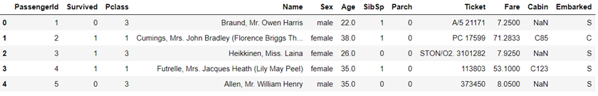

#### Data after Data Engineering

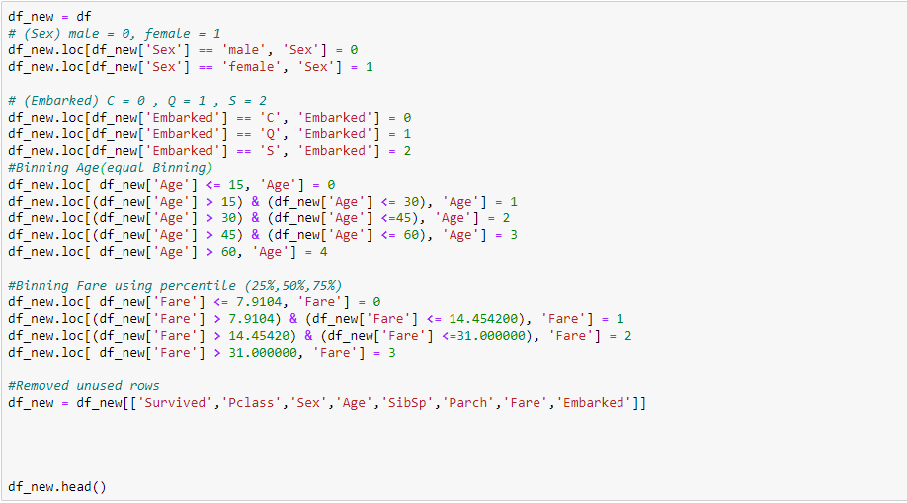

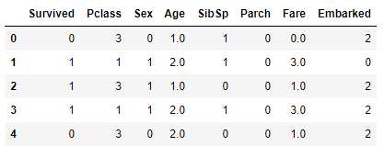

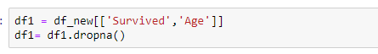

Removing unused features and changing sex and embarked to integer allows new features to be used for training Logistic Regression data model. As the logistic regression model does not accept NaN as value. Samples are also deleted in the event that there is missing data.

#### Model 1

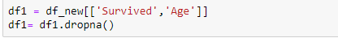

Having Age as the only independent variable to predict the survival rate.

Time taken 0.0070 seconds

The accuracy score is 57.54%.

Confusion matrix

|  |  |  |
| --- | --- | --- |
|  | Predicted Positive | Predicted Negative |
| Actual Positive | 0 | 76 |
| Actual Negative | 0 | 103 |

#### ***Model*** 2

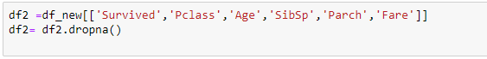

This training model include using Pclass, Age, SibSp, Parch, Fare as its independent variable.

Time taken 0.0069 seconds

The accuracy score is 65.92%.

Confusion matrix

|  |  |  |
| --- | --- | --- |
|  | Predicted Positive | Predicted Negative |
| Actual Positive | 35 | 41 |
| Actual Negative | 20 | 83 |

#### Model 3



This training model include using Pclass, SibSp, Parch, Fare as its independent variable.

Time taken 0.0089 seconds

The accuracy score is 71.30%.

Confusion matrix

|  |  |  |
| --- | --- | --- |
|  | Predicted Positive | Predicted Negative |
| Actual Positive | 40 | 44 |
| Actual Negative | 20 | 119 |

#### Model 4

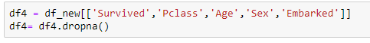

This training model include using Pclass, Age, Sex, Embarked as its independent variable.

Time taken 0.0060 seconds

The having accuracy score is 79.77%.

Confusion matrix

|  |  |  |
| --- | --- | --- |
|  | Predicted Positive | Predicted Negative |
| Actual Positive | 54 | 20 |
| Actual Negative | 16 | 88 |

#### Model 5

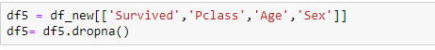

This training model include using Pclass, Age, Sex as its independent variable.

Time taken 0.0070 seconds

The having accuracy score is 82.12%.

  Confusion matrix

|  |  |  |
| --- | --- | --- |
|  | Predicted Positive | Predicted Negative |
| Actual Positive | 59 | 17 |
| Actual Negative | 15 | 88 |

### Impact of data engineering & feature engineering

Looking at model 1 confusion matrix, the model predicts that all the passengers will not survive. This shows that using age as the only independent variable to train the model will resulting it to be highly inaccurate (57.54%), unable to predict for any survivors. This is due to underfitting as the model is overly simple, having only one independent variable. We need to increase the number of features to train the model, for the model to be able to predict survivors.

Comparing model 2 and 3. Model 2 uses Pclass, Age, SibSp, Parch, Fare as its independent variable. Model 3 uses the same variables except for removing Age. The accuracy score increased from 65.92% to 71.30%. The accuracy difference between the models might be due to overfitted for model 2 having too many features, being too complex. Removing some features will increase the accuracy.

Models 4 and 5 are created after looking at the correlation of the variables. Using df_new.corr(), looking at the correlation of the features, removing highly correlated information in the independent variables and removing variables that are not correlated with the survival rate.

After testing with several models, we found that using 3 to 4 labels produces the highest accuracy. Taking into consideration of the correlation, training and testing different permutations of the features. Model 5 produces the highest accuracy of 82.12%

### Other observations

Time taken to train the models comparing model 1 and model 3 time taken 0.0069 seconds and 0.0089 seconds respectively. Although there is a slight increase in the take taken, the difference is not significant. This might be due to small size of the dataset. Having either too many or too little labels in training the model will result in the model being less accurate. By choosing suitable number of labels and choosing the right labels to train the model will result in a higher accuracy.

## (2) K-NN classification

### Duration of training

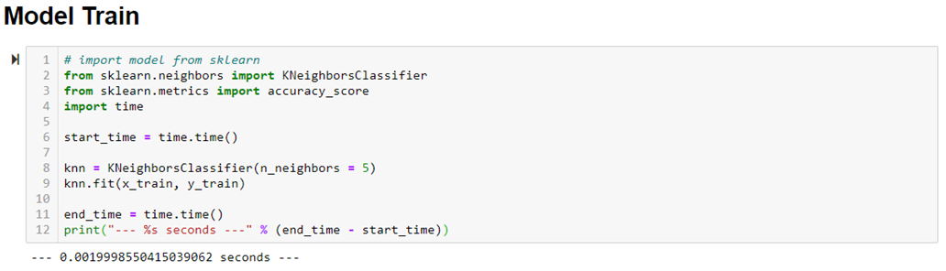

### Sharing of the process

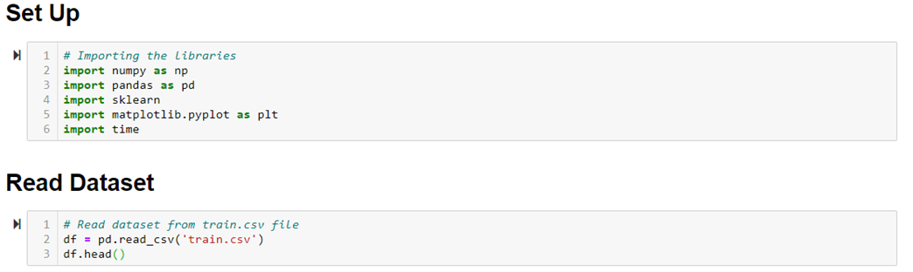

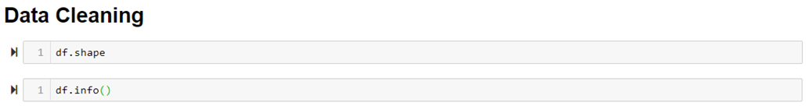



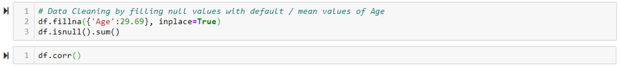

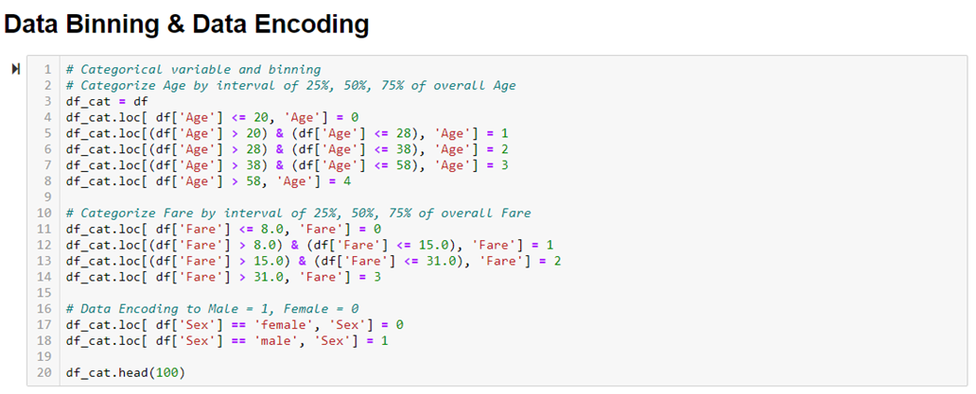



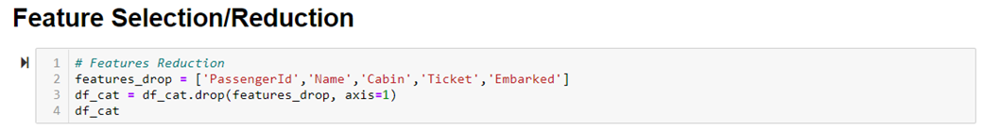



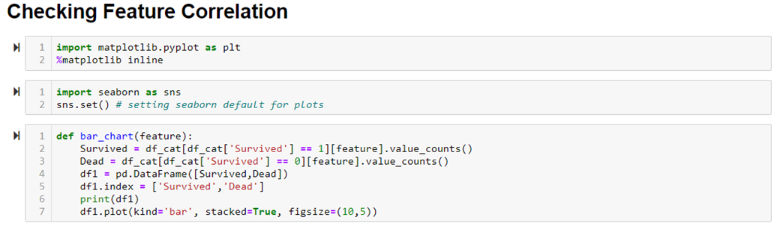

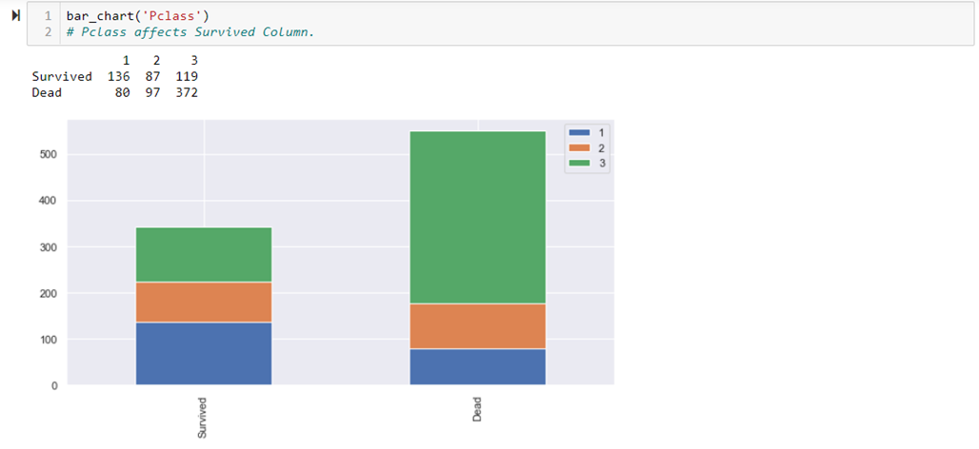

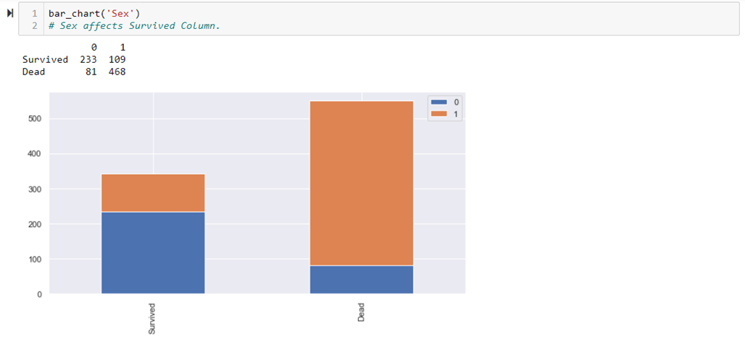

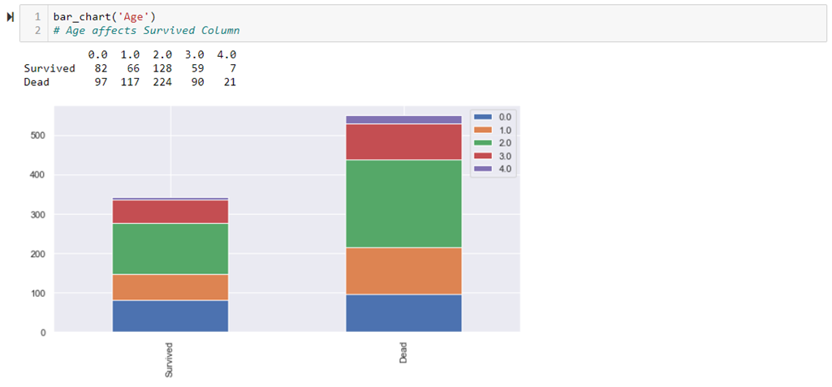

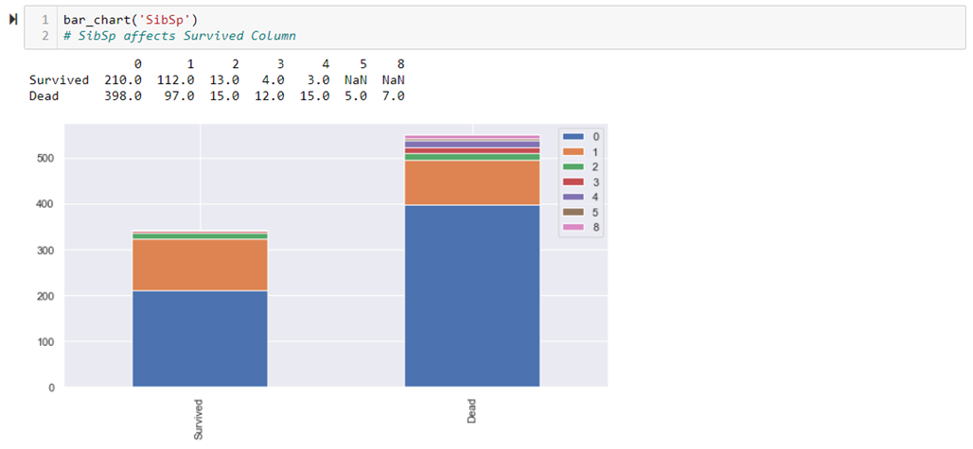

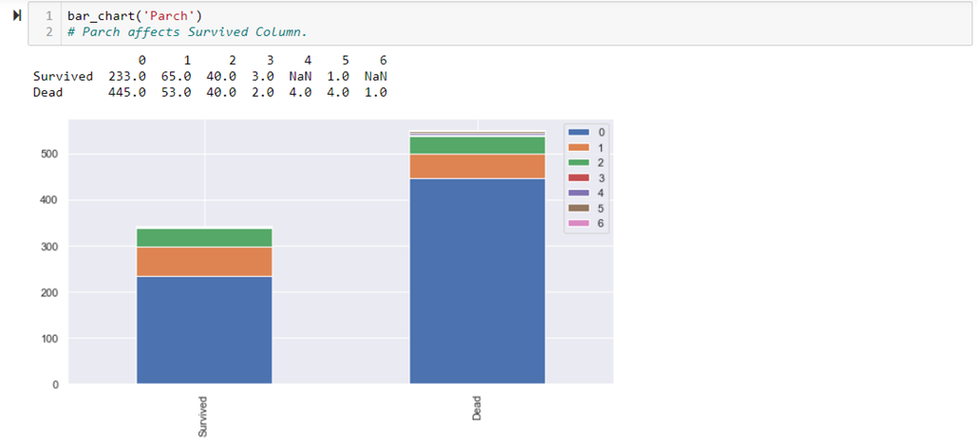

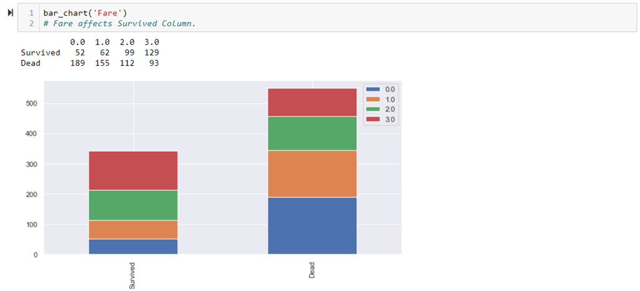

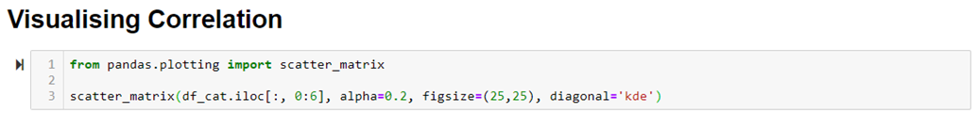

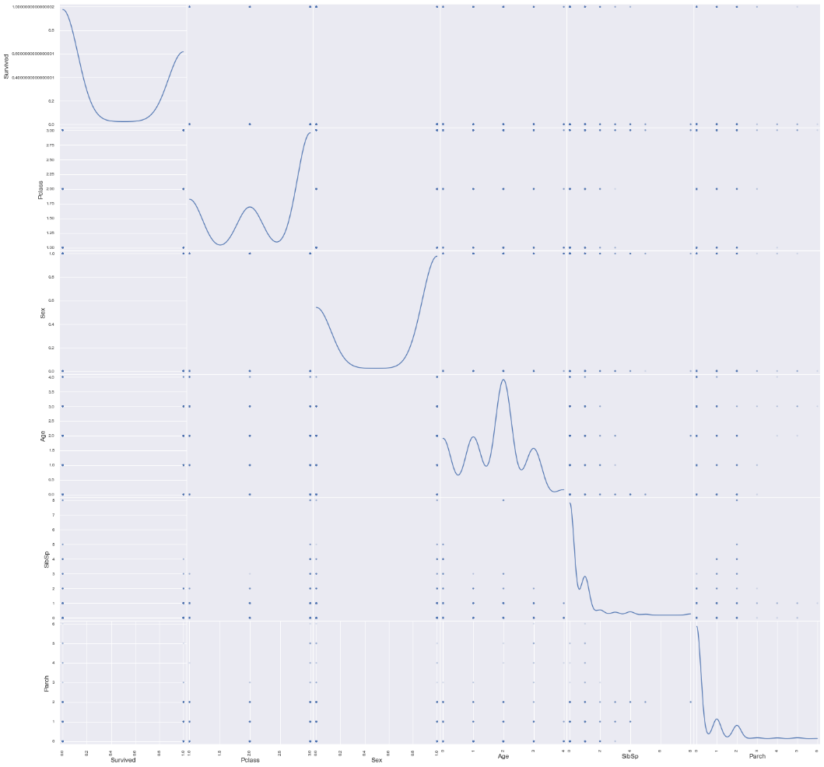



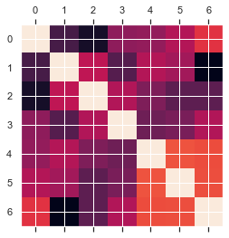



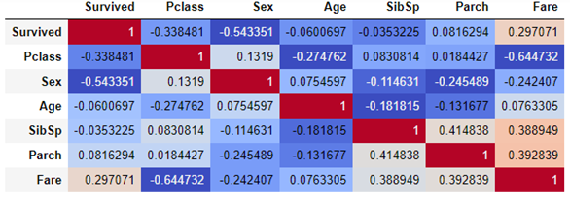

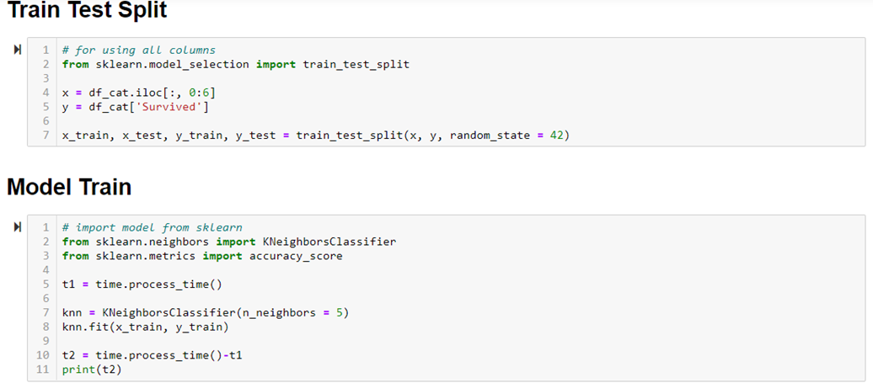

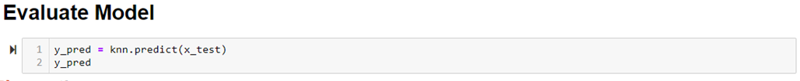

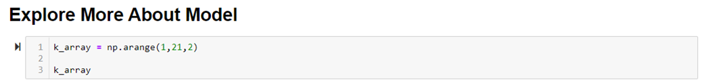

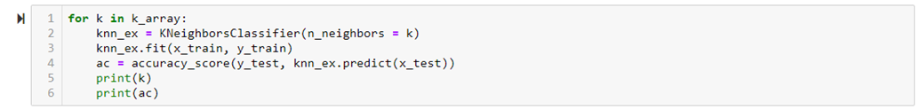



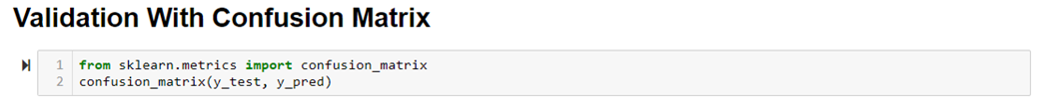





##### Raw Data overview

Read in the raw dataset, rename the column name for better handling. The raw data has 891 rows and 11 columns.



##### First time data engineering and model building

Realized there are 177 null in age, and 687 null value. Drop all null value, the valid data set has 183 rows and 11 columns.

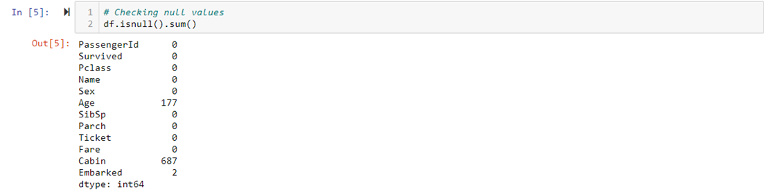

There are two options for null values. (1) To drop the rows including null values. (2) To replace the rows with the default or mean value of that feature. We choose (2) to replace by default or mean value of overall Age from the dataset. Null values from Cabin column will remain as we will drop this column in later stage.

##### Data Binning

The feature ‘Age’ is converted from continuous data into numeric categorical values by interval of 25%, 50%, 75% of the overall Age. Therefore, Age <= 20 will be 0.  Age > 20 and Age <= 28 will be 1. Age > 28 and Age <= 38 will be 2. Age > 38 and Age <= 58 will be 3. Age > 58 will be 4.

The feature ‘Fare’  is converted continuous data into numeric categorical values by interval of 25%, 50%, 75% of the overall Fare. Therefore, Fare <= 8.0 will be 0. Fare > 8.0 and Fare <= 15.0 will be 1. Fare > 15.0 amd Fare <= 31.0 will be 2. Fare > 31.0 will be 3.

##### Data Encoding

The feature ‘Sex’ is converted from categorical text into numeric values. Therefore, male = 1 and female = 0.

##### Feature Selection / Reduction

The features PassengerId, Name, Cabin, Ticket, Embarked are being dropped by using ‘df_cat.drop (features_drop, axis=1)’ as they are unnecessary features from dataset. Select “Pclass, Sex, Age, Sibsp, Parch, Fare” as the features to estimate “Survived”. Already modified the data type of ‘Sex’ into integer for model training. Validation with Confusion Matrix: Having 'Pclass','Sex','Age', ’SibSp’, 'Parch' and ‘Fare' as the independent variables to predict the survival rate. The accuracy score is 96.86%. The snippet below illustrates the following

Confusion matrix

|  |  |  |
| --- | --- | --- |
|  | Predicted Positive | Predicted Negative |
| Actual Positive | 131 | 3 |
| Actual Negative | 4 | 85 |

### Impact of data engineering & feature engineering

The first model’s accuracy without doing data engineering, feature engineering and model engineering is from 0.6086 to 0.7391.

The last model’s accuracy after doing data engineering, feature engineering and model engineering is from 0.9686 to 0.9955.

### Other observations

The accuracy before doing data engineering and featuring engineering while modelling the dataset were around 71%. When the number of features were five and all the features were of low correlated the accuracy of the model reached 98%.

### 

## (3) Decision trees

### Duration of training

Model 1: 0.78sec

Model 2: 0.73sec

Model 3: 0.75sec

Model 4: 0.005sec

### Sharing of the process

Data before Data Engineering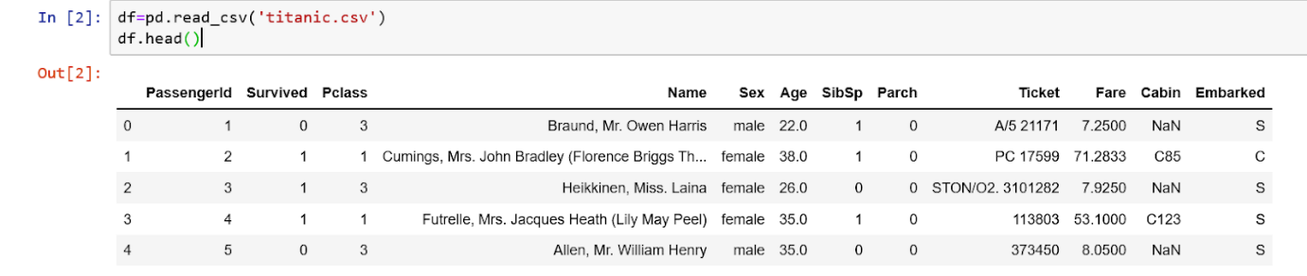

Data after Data Engineering

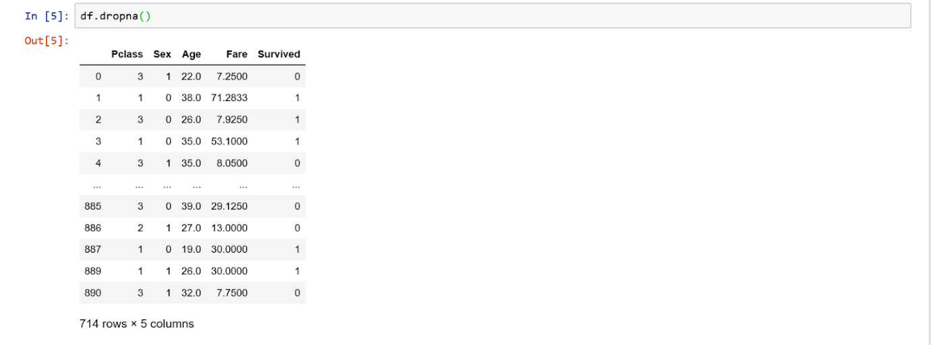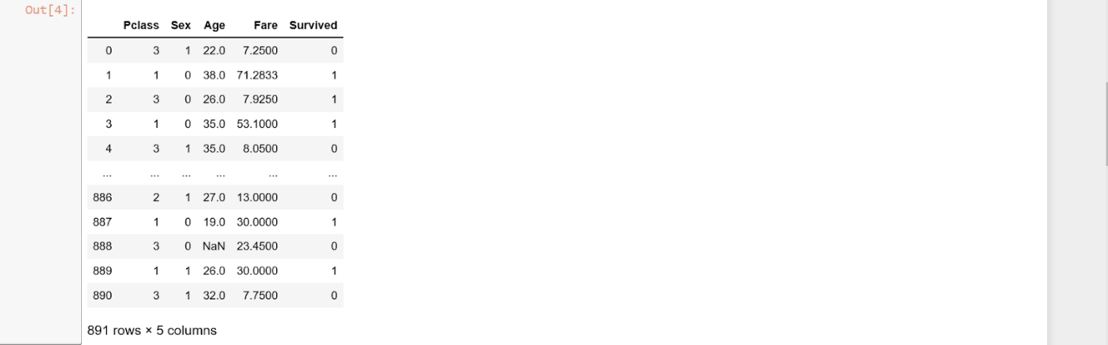

#### Model 1

Having ‘Pclass’ and ‘Fare’ as the independent variables to predict the survival rate which is the dependent variable. The code for the feature selection is below

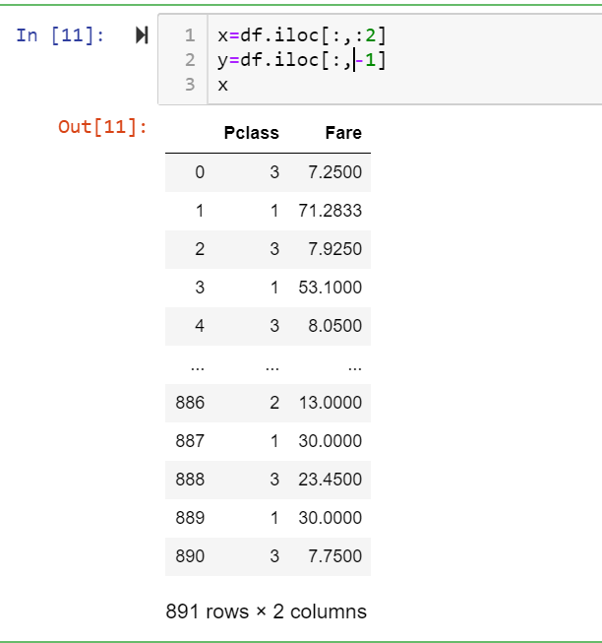

We got the accuracy score as 69.95%. The below snippet illustrates the code

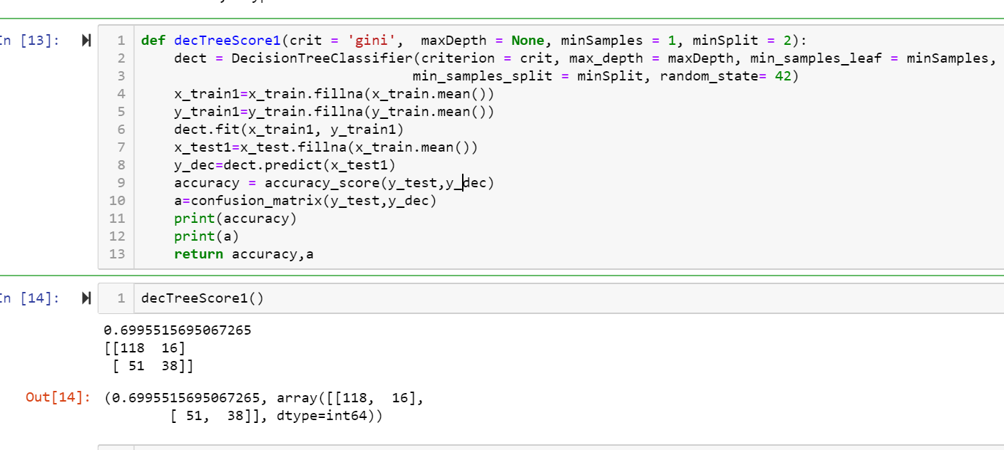

The confusion matrix for the model is as below, where there are 66% of wrongly predicted data.

Confusion matrix

|  |  |  |
| --- | --- | --- |
|  | Predicted Positive | Predicted Negative |
| Actual Positive | 118 | 16 |
| Actual Negative | 51 | 38 |

#### Model 2

Having 'Pclass', 'Sex', 'Age', 'Parch' and ‘'Fare' as the independent variables to predict the survival rate.

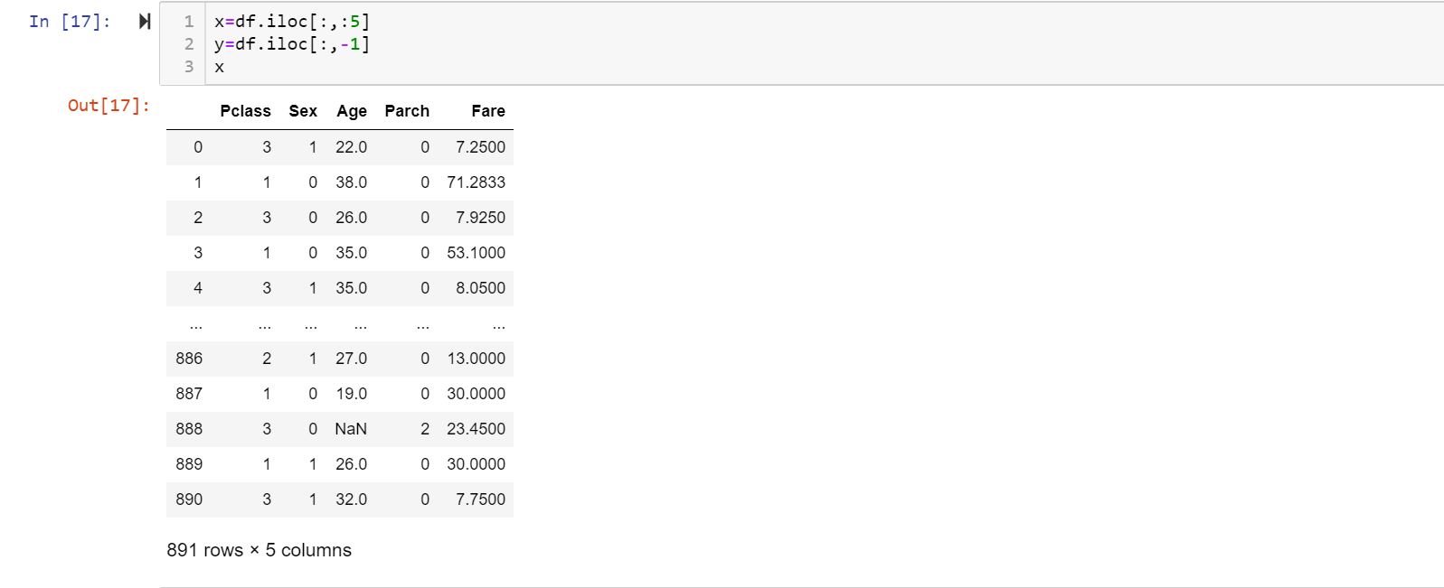

The accuracy score is 73.99%. The snippet below illustrates the following

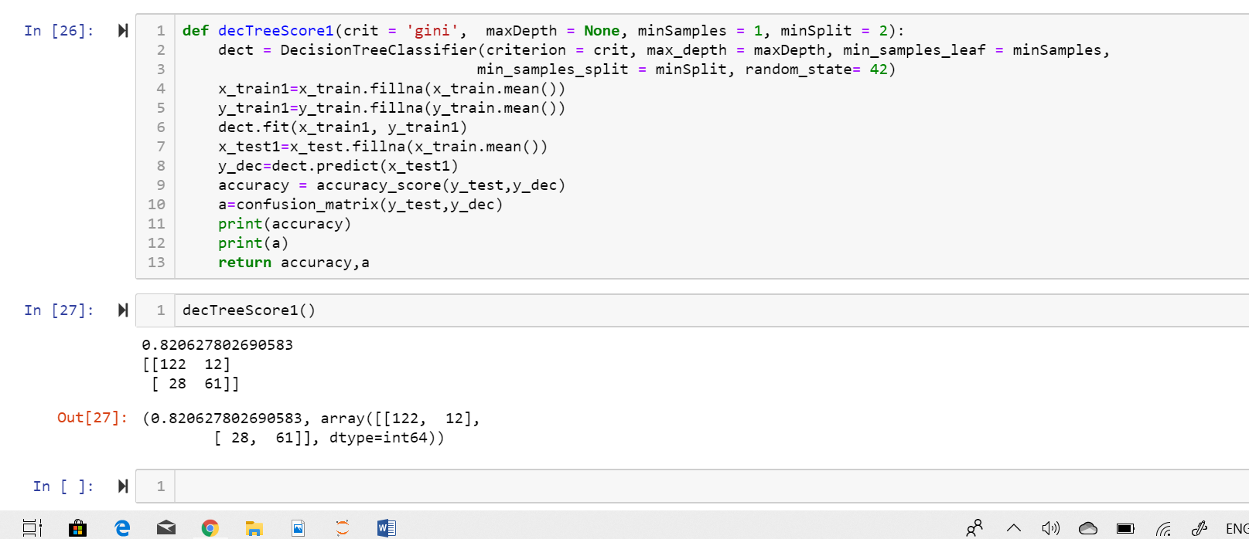

Confusion matrix

|  |  |  |
| --- | --- | --- |
|  | Predicted Positive | Predicted Negative |
| Actual Positive | 122 | 12 |
| Actual Negative | 28 | 61 |

Model 3

Having 'Pclass','Sex','Age' and 'Fare' as the independent variables to predict the survival rate.

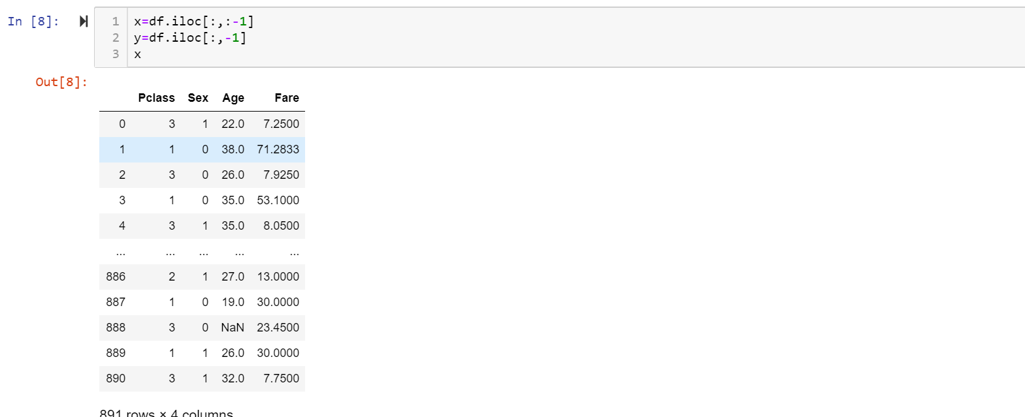

The accuracy score is 81.61% which is achieved with the below code doing iteration for finding the highest accuracy.

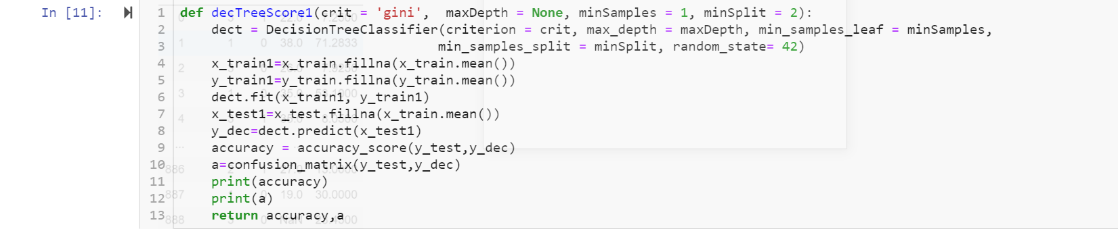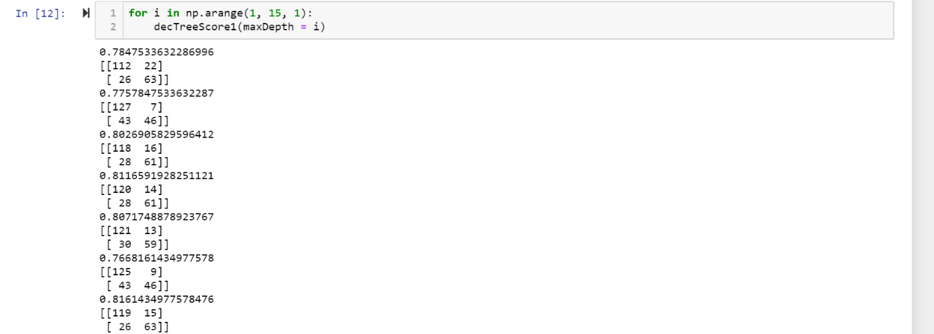

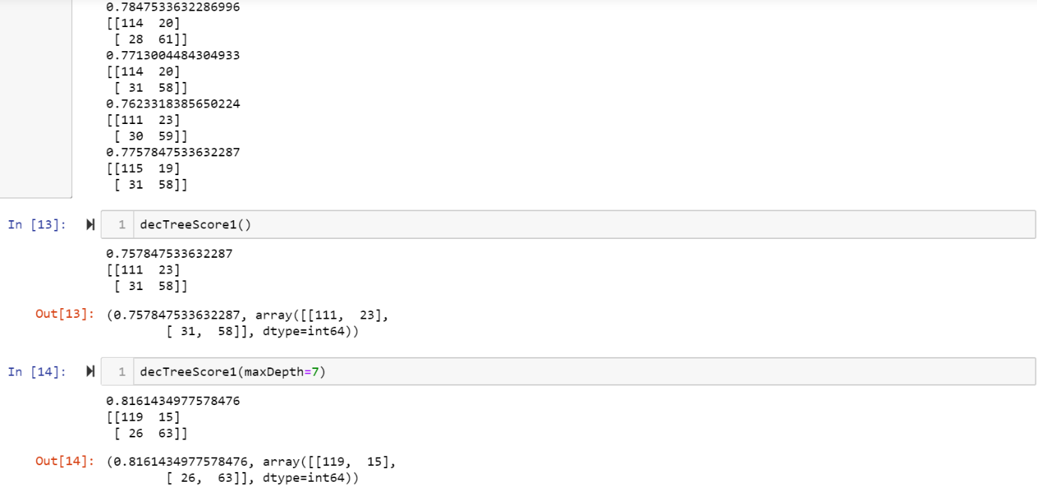

Confusion matrix

|  |  |  |
| --- | --- | --- |
|  | Predicted Positive | Predicted Negative |
| Actual Positive | 119 | 15 |
| Actual Negative | 26 | 63 |

#### Model 4

Finally having 'Pclass','Sex' and 'Fare' as the independent variables to predict the survival rate.

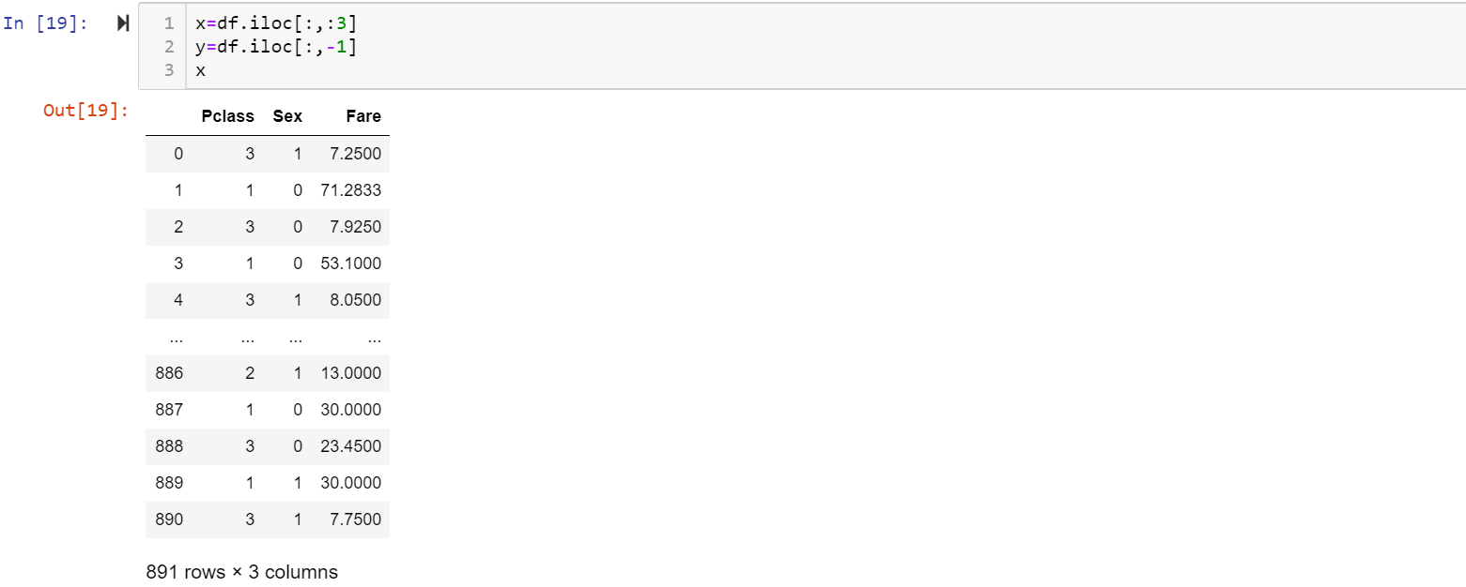

For depth=2, the accuracy score is 78.02% is achieved with below code

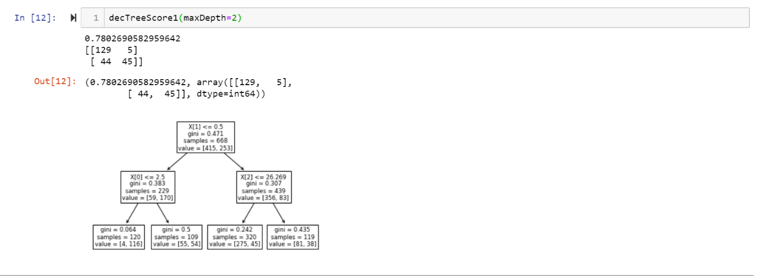

For depth=9, the accuracy is highest and is 82.51%

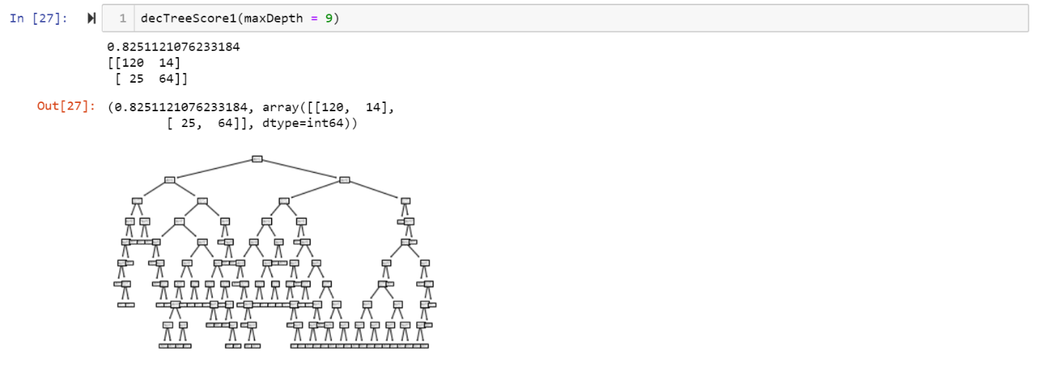

Confusion matrix

|  |  |  |
| --- | --- | --- |
|  | Predicted Positive | Predicted Negative |
| Actual Positive | 120 | 14 |
| Actual Negative | 25 | 64 |

### Impact of data engineering & feature engineering

We are trying with different n_neighbors. By using n_neighbors as '3' has an accuracy rate of 0.98206 and n_neighbors as '5' has an accuracy rate of 0.99551. As we would like to predict accuracy of above 90% of the information during the process, we will use n_neighbors as 5 with accuracy of 0.99551.

By doing data encoding and data binning, it’s much more easier to visualize the relation between the features and the target in bar chart clearly. We could use bar chart, scatter matrix and heat map to find the relation and correlation between them. According to bar charts, we could know that the certain features like ‘Pclass’, ‘Sex’, ‘Age’, ‘SibSp’, ‘Parch’, and ‘Fare’ have strong relationships with the independent variable ‘Survived’. So, we can assume that weak relations and unaffected features could be dropped after that.

Not only the higher accuracy rate but also the faster training duration can be done by doing data engineering and feature engineering. The time duration for training the model reduced from 0.0020 seconds and 0.0019 seconds. And also the accuracy rate is increased from 0.71521 to 0.98026.

### Other observations

The accuracy when having less or a greater number of features / dimensions while modelling the dataset were around 70%. When the number of features were three and all the features were of low correlated the accuracy of the model reached 82%.

### Conclusion (model that yields the best outcome)

|  |  |
| --- | --- |
| **Model** | **Accuracy** |
| Linear regression | 91.98% |
| Logistic regression | 82.12% |
| K-NN classification | 99.55% |
| Decision trees | 82.51% |

On comparing with all other models of classification, K-NN is most powerful and has higher accuracy for this dataset. And the highest accuracy is achieved with a smaller number of models.

# Part 2: Unsupervised Machine Learning

### Problem statement

Our goal is to try to group similar observations together and determine the number of possible clusters (it may differ from 2). This would help us make predictions and reduce dimensionality.

The dataset is related to variants of the Portuguese "Vinho Verde" white wine. We take it as a clustering task. Column ‘quality’ is the benchmark result we want. Column ‘1-11’ are chemical content data. We planned to use Unsupervised Machine Learning method to cluster the dataset into groups as in column ’quality’. Since there are many more normal wines than excellent or poor ones, it will be quite a challenge.

With the dataset we are trying to group them in clusters to determine the quality of the wine.

With the dataset we are trying to group them in clusters. Noted that the dataset is actually labelled with ‘quality’, however, we are not going to use it and do a supervised learning here. Instead, we will do unsupervised clustering and let the machine to group these wines into different groups based on their own characteristics. It is very likely; the clusters do not correspond to the original label. For instance, the machine may not be grouping the wines by ‘quality’ but by ‘taste’, wines fall into the same cluster might taste similar but quality can be very different. Or even if the machine did cluster the wine by their quality, the machine might have a totally different standards for quality.

Therefore, this study is mainly intended to provide a machine-based clustering so as to provide a different perspective for people to understand and evaluate the wines based on the grouping.

### Data dictionary

|  |  |  |
| --- | --- | --- |
| **Variable** | **Type** | **Definition** |
| fixed acidity | float64 | Fixed acidity, most acids involved with wine or fixed or non-volatile (do not evaporate readily) |
| volatile acidity | float64 | Volatile acidity, the amount of acetic acid in wine, which at too high of levels can lead to an unpleasant, vinegar taste |
| citric acid | float64 | Citric acid, the amount of acetic acid in wine, which at too high of levels can lead to an unpleasant, vinegar taste |
| residual sugar | float64 | Residual sugar, the amount of sugar remaining after fermentation stops, it's rare to find wines with less than 1 gram/liter and wines with greater than 45 grams/liter are considered sweet |
| chlorides | float64 | Chlorides, the amount of salt in the wine |
| free sulfur dioxide | float64 | Free sulfur dioxide, the free form of SO2 exists in equilibrium between molecular SO2 (as a dissolved gas) and bisulfite ion; it prevents microbial growth and the oxidation of wine |
| total sulfur dioxide | float64 | Total sulfur dioxide, amount of free and bound forms of S02; in low concentrations, SO2 is mostly undetectable in wine, but at free SO2 concentrations over 50 ppm, SO2 becomes evident in the nose and taste of wine |
| density | float64 | Density, the density of water is close to that of water depending on the percent alcohol and sugar content |
| pH | float64 | pH, describes how acidic or basic a wine is on a scale from 0 (very acidic) to 14 (very basic); most wines are between 3-4 on the pH scale |
| sulphates | float64 | Sulphates, a wine additive which can contribute to sulfur dioxide gas (S02) levels, which acts as an antimicrobial and antioxidant |
| alcohol | float64 | The percent alcohol content of the wine |
| quality | int64 | Quality score between 0 and 10 |

### Source of dataset

<https://archive.ics.uci.edu/ml/datasets/Wine+Quality>a)

## a) K-means (with & without PCA)

### Duration of training

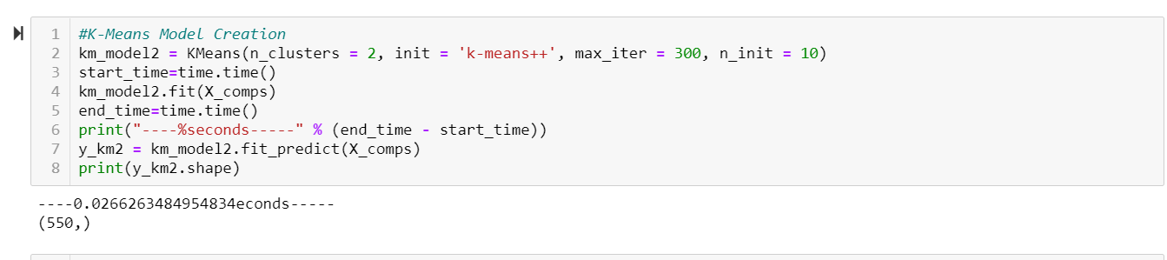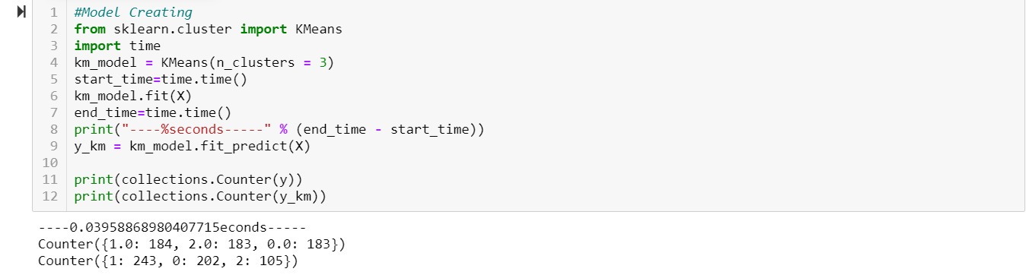

### Sharing of the process

The first step is importing all the required libraries and the dataset.

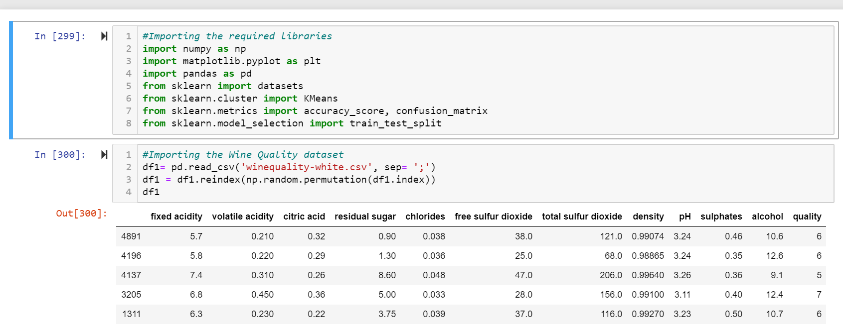

From the dataset we found that the quality of the wine ranges from 3 to 9, forming 7 clusters. Hence, we find the number of clusters using K-means algorithm. Now we are binning the quality from 0-2 so that the quality 3 and 4 both together form the new quality 0 , 1 and so on.

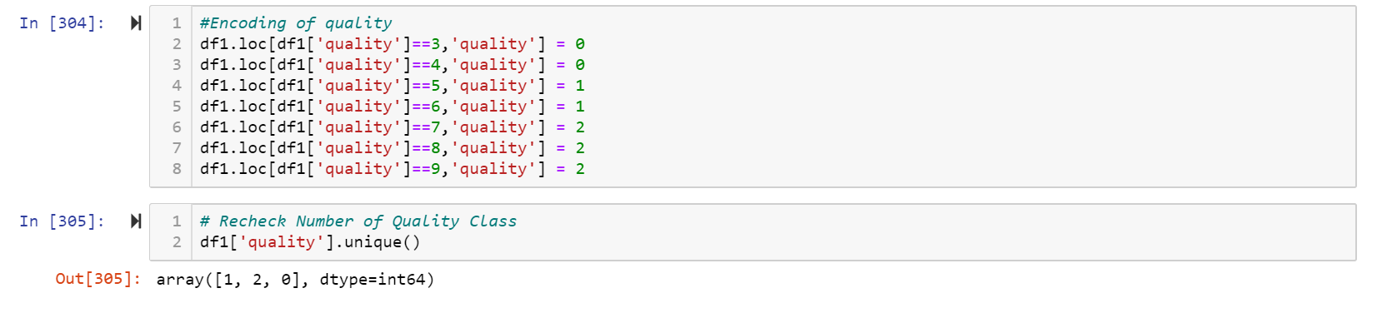

After binning, we split the dataset, the quality which is the outcome of the model is determined from all the features listed in the table. So, except for quality the rest of the columns are chosen as X (independent variable).

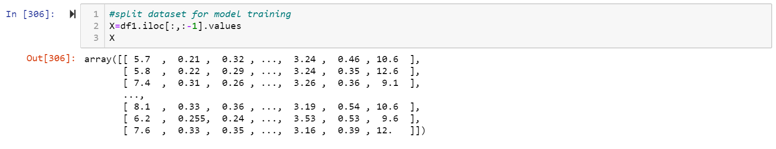

After splitting the dataset, using Elbow method we now determine the value of ‘k’, using the WCSS (Within- clusters sum of squares) vs the number of clusters along the axis.

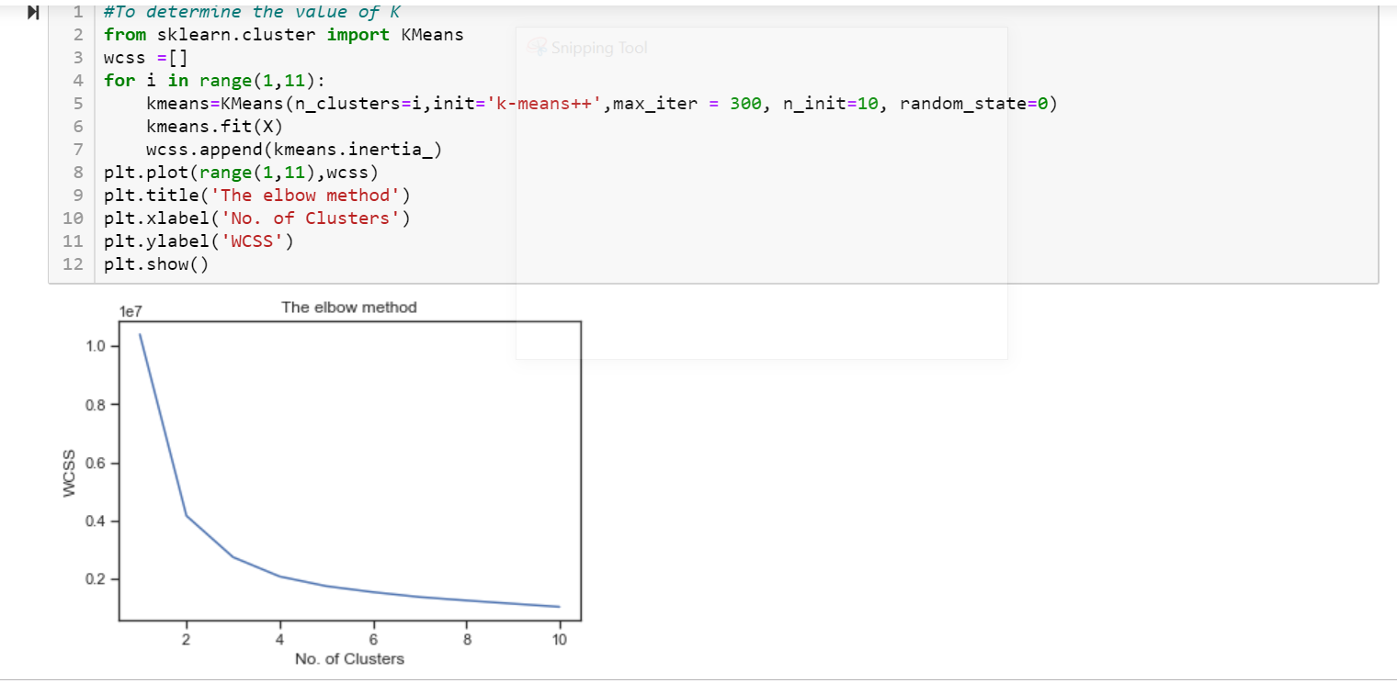

From the above graph the K is prominently constant or decreasing after K=3.

The number of rows and columns in our training data is

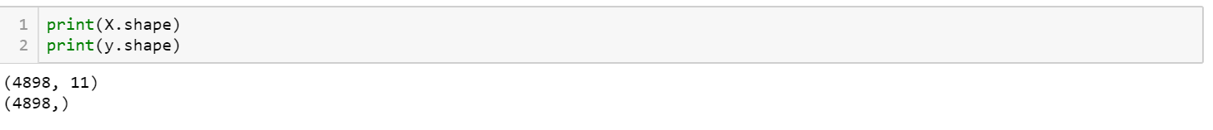

To measure the covariance between each columns s that the one of two highly correlated column is removed to improve the model building, we use scatter matrix.

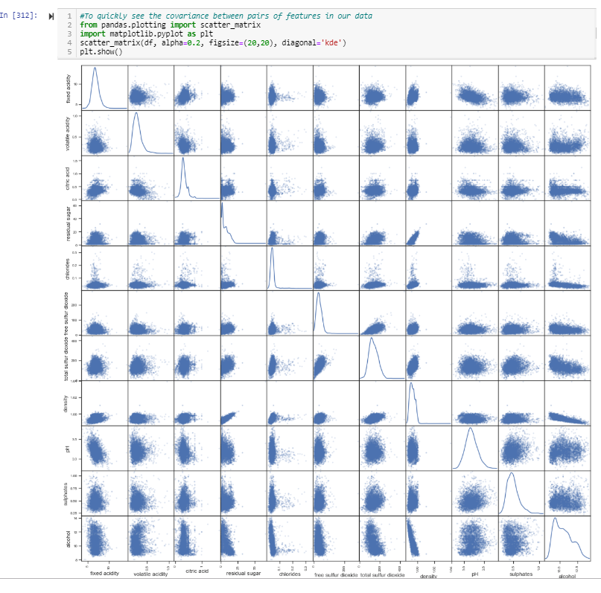

The distribution of the dataset is shown below. Before Smooth Bias for classes and rows are

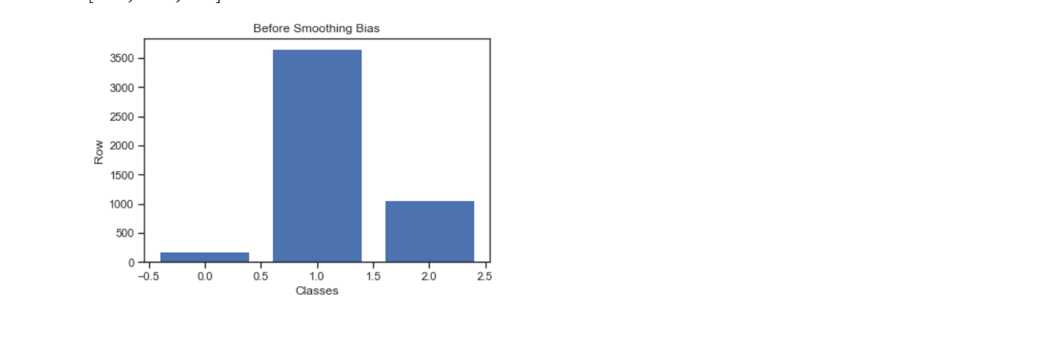

Some features are removed and two clusters are estimated with having 183 rows. Now the after smooth bias has equal number of distributions for each class.

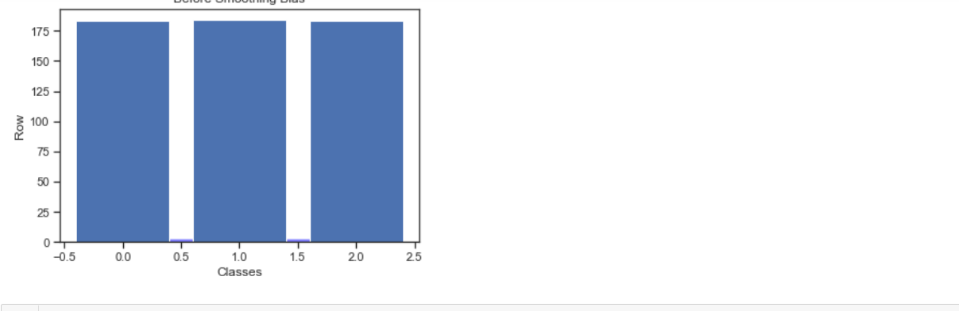

We would like to visualize these results; the plot looks quite decent.

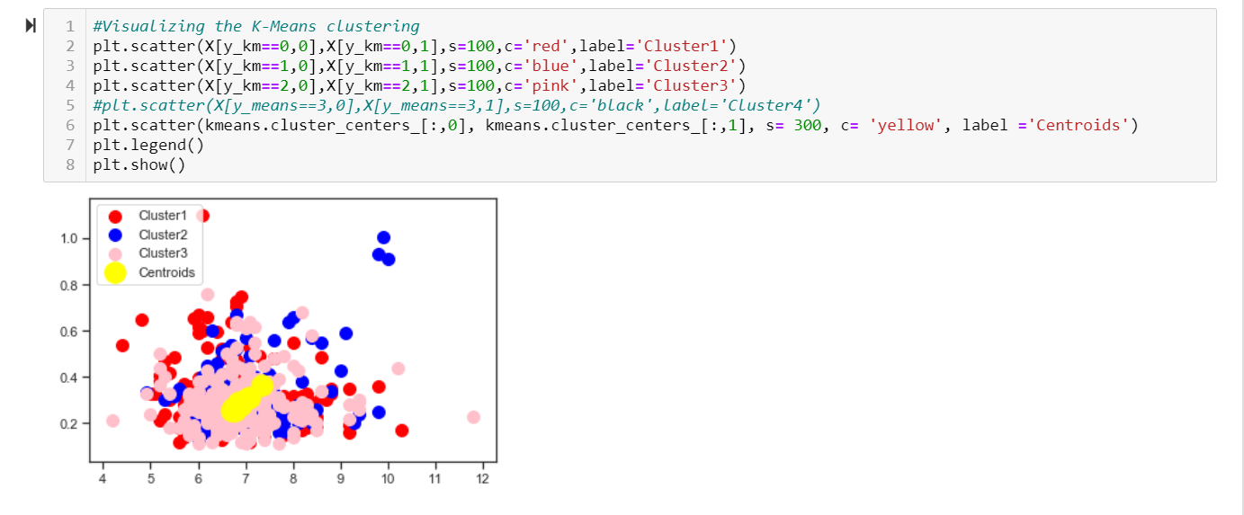

To verify the type of quality and to the cluster they belong to

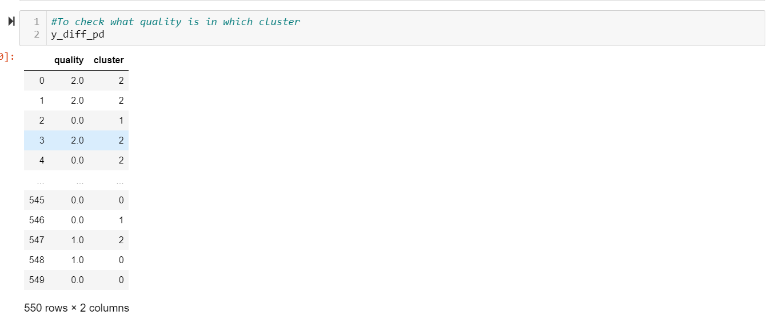

The accuracy of the model is achieved by

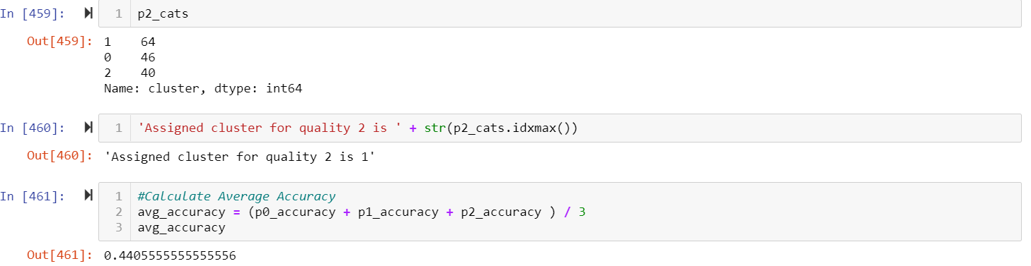

The better results can be achieved with PCA.

The standard scale for each feature is found, and the two PCA variables are found as follows.

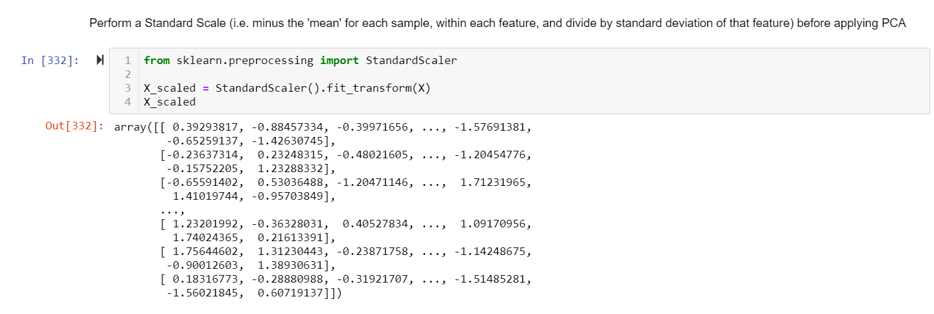

The new variable is now the PCA variable, which helps in finding the explained variance ratio.

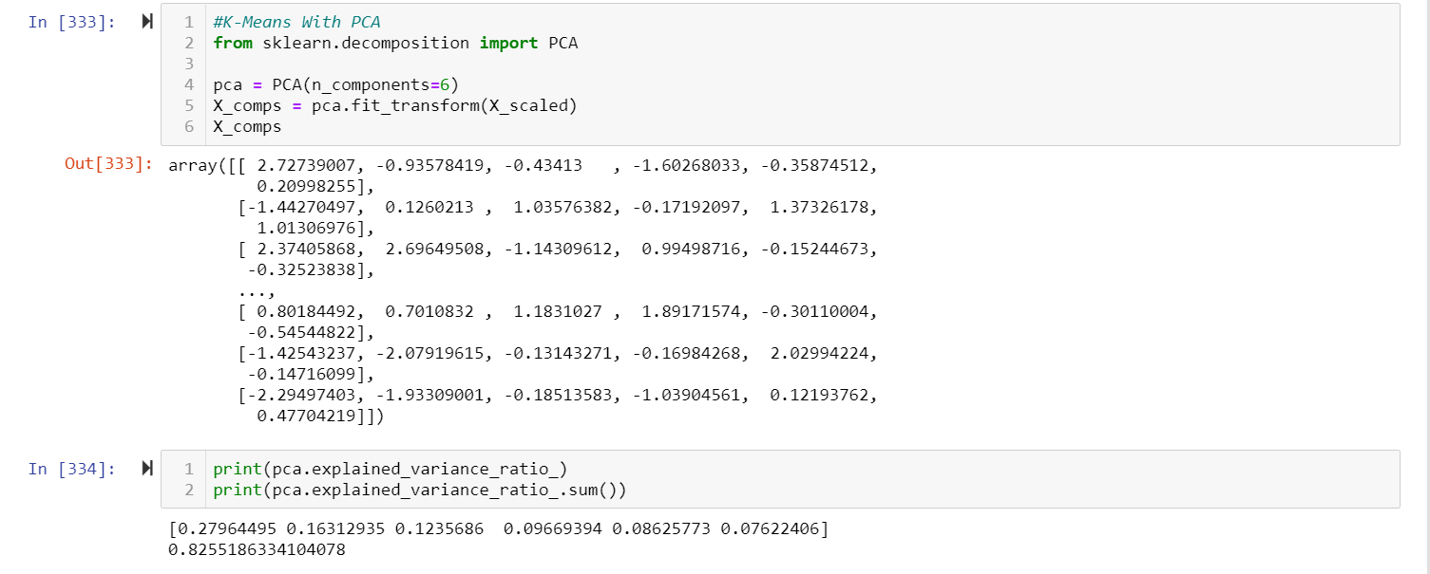

The WCSS vs Number of clusters graph is used for finding K. This is done by Elbow method. The obtained k is 2.

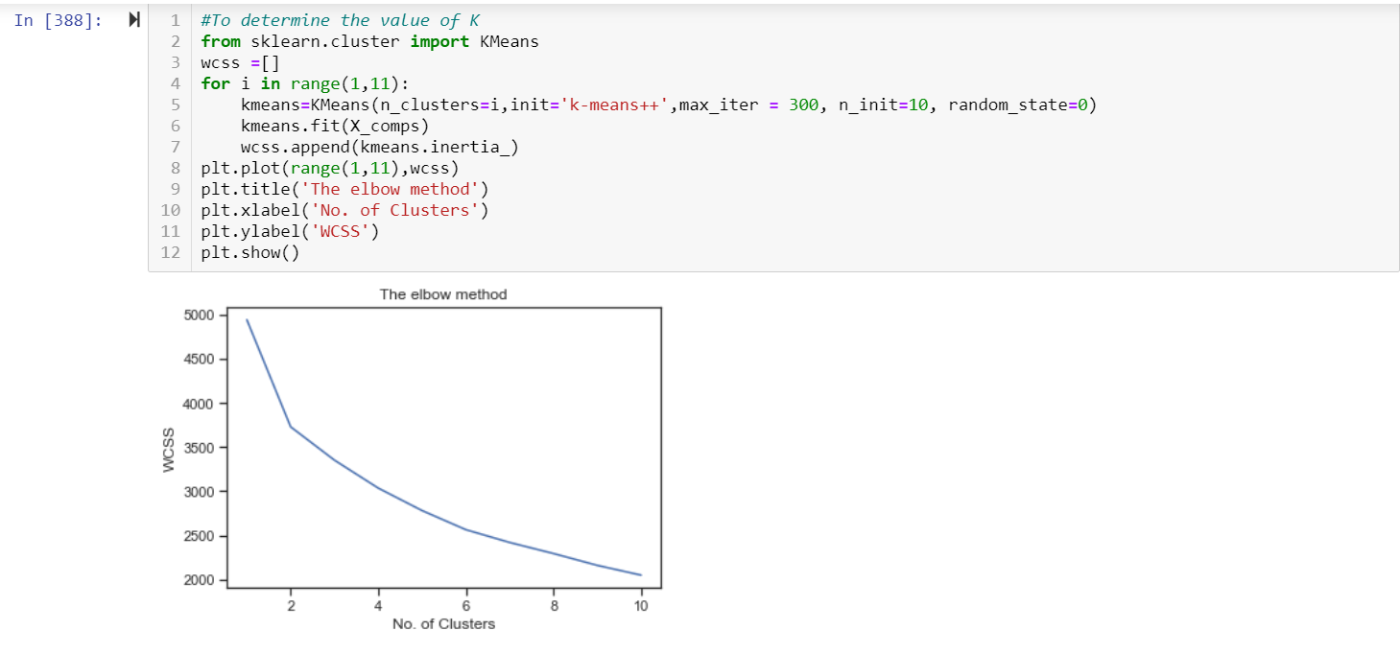

The model now looks more or less similar to the previous model, but with better understanding and it also contains all the possible information present in the dataset.

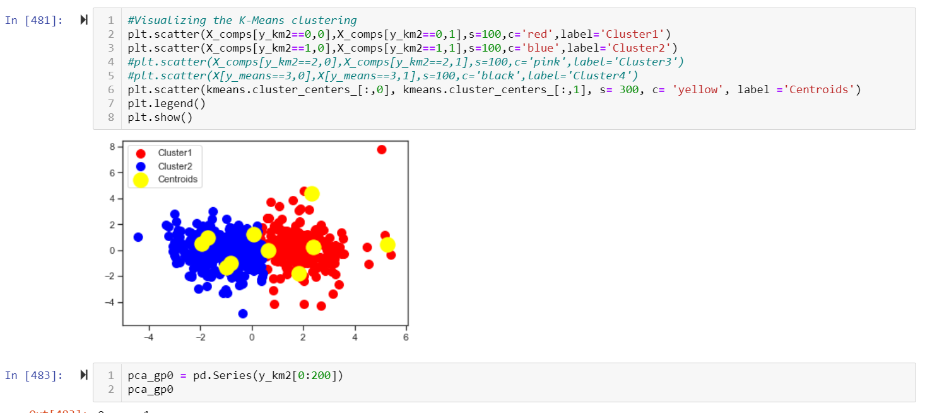

The accuracy achieved with PCA model is 0.6673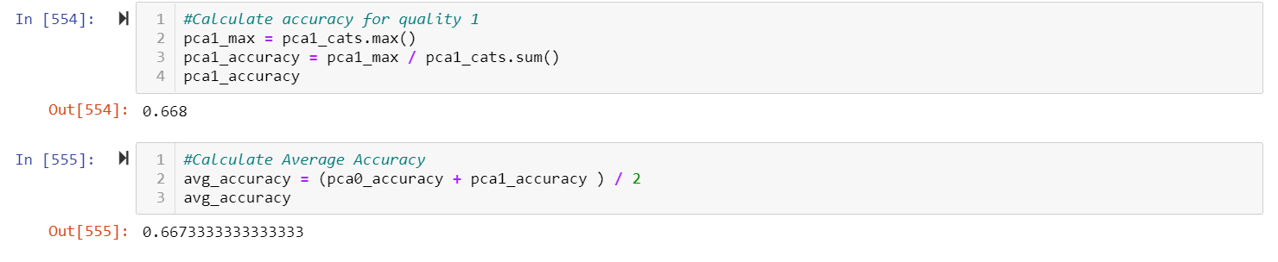

### Impact of data engineering & feature engineering

Initially, the model without applying PCA had 3 clusters and accuracy is also only 44%. The PCA is applied to reduce the dimensions of the dataset, so that the model has only two independent variables PCA1 and PCA2. This shows that the highly correlated variables are combined the new variables are functions of the original variable.

After applying PCA, the accuracy of the model increased 20 %. So, the accuracy with PCA now is 66%. Hence applying PCA reduces the dimensionality of the model.

### Other observations

It is clear that applying K-means clustering in the PCA, all the information of the dataset is included. As the dimensions are reduced, the results systematically and significantly improved.

The accuracy achieved with PCA is 66% whereas the accuracy without PCA is only 44%. From this it is understood that betterment of the model takes place while implementing clustering in the PCA.

Here is also the plot of how the value of K varies between cluster and within clusters.

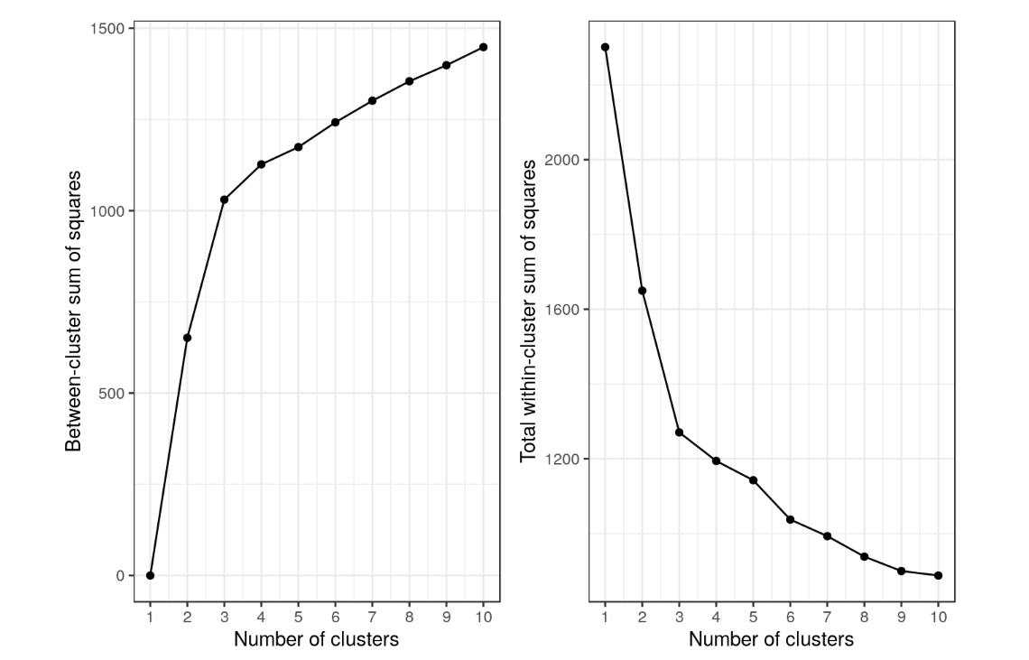

## b) Agglomerative (Hierarchical) clustering (with & without PCA)

### Duration of training

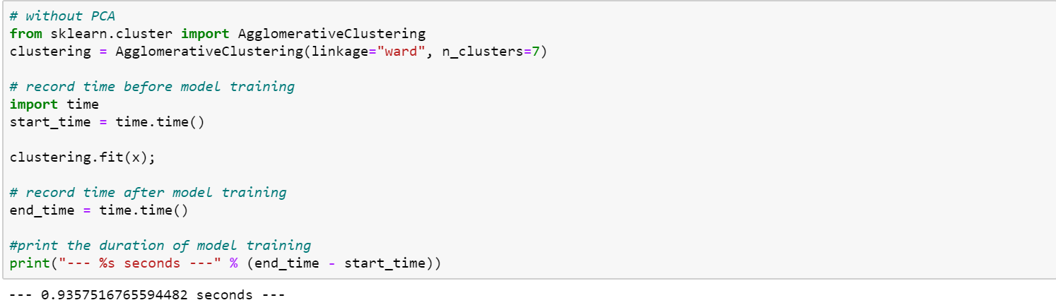

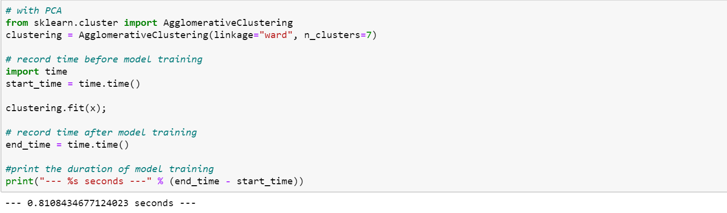

### Sharing of the process

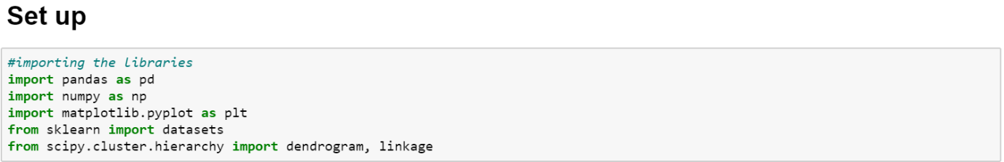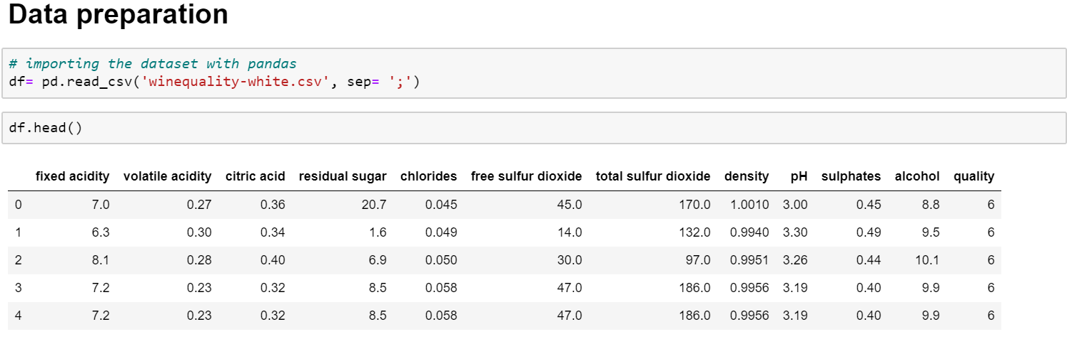

Firstly, we conducted Hierarchical clustering. The data quality was good and there were no missing values that need to be imputed. While all the features are numerical, and their ranges differs a lot. For instance, ‘free sulfur dioxide’ of value 170.0 is much huge than ‘sulphates’ of value 0.45. Therefore, I applied standard min/max scaling on all the feature columns to normalize the data within a range.

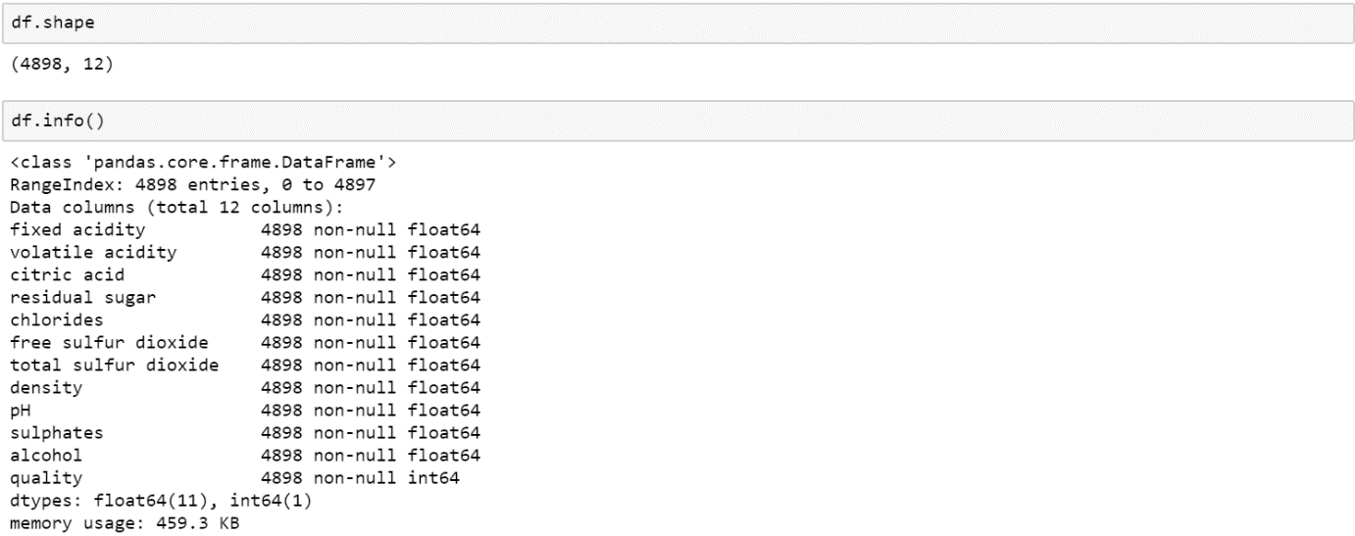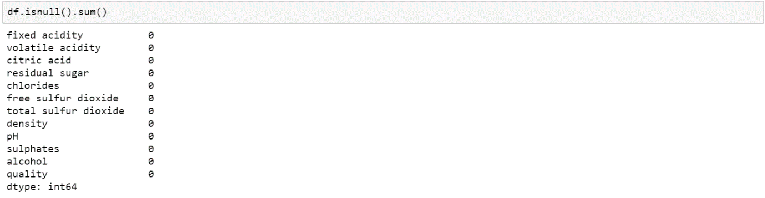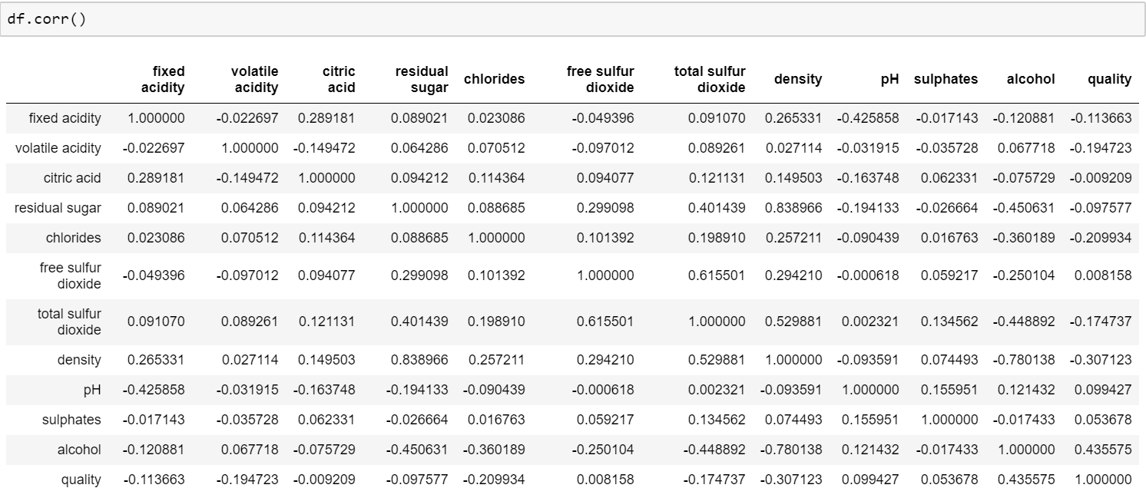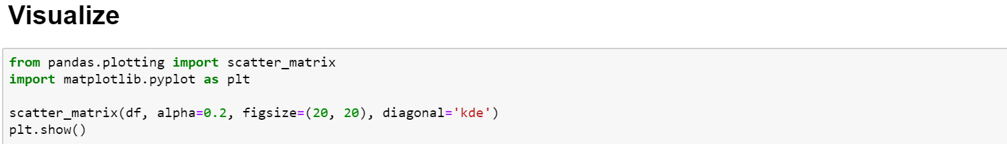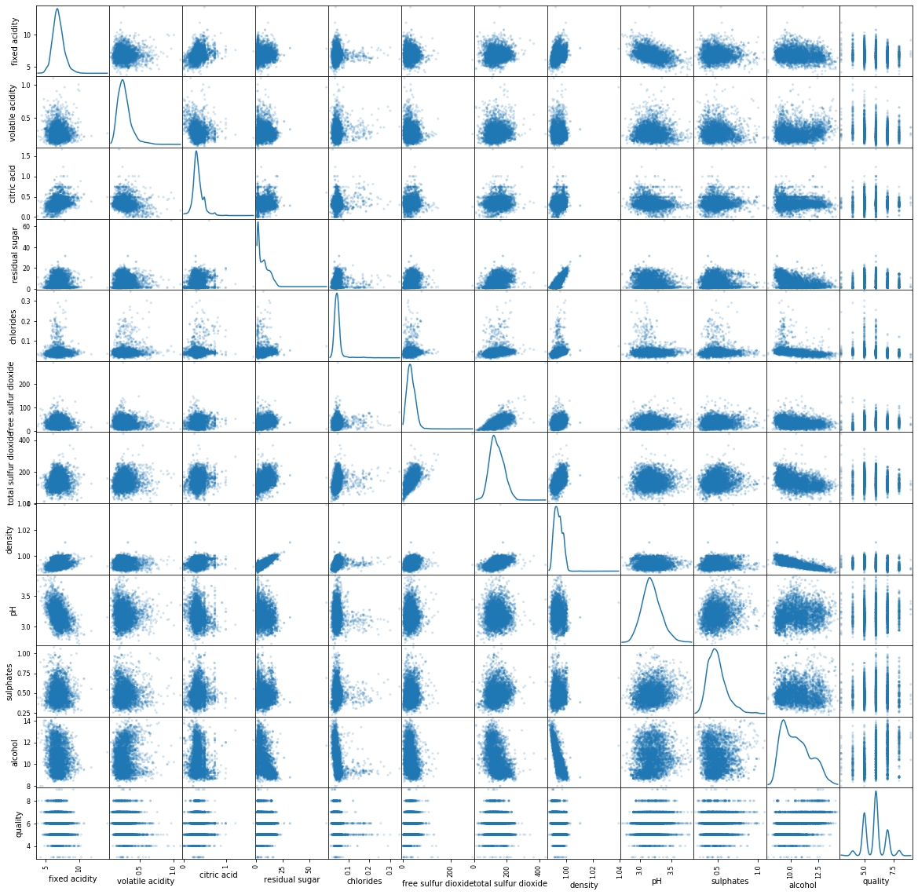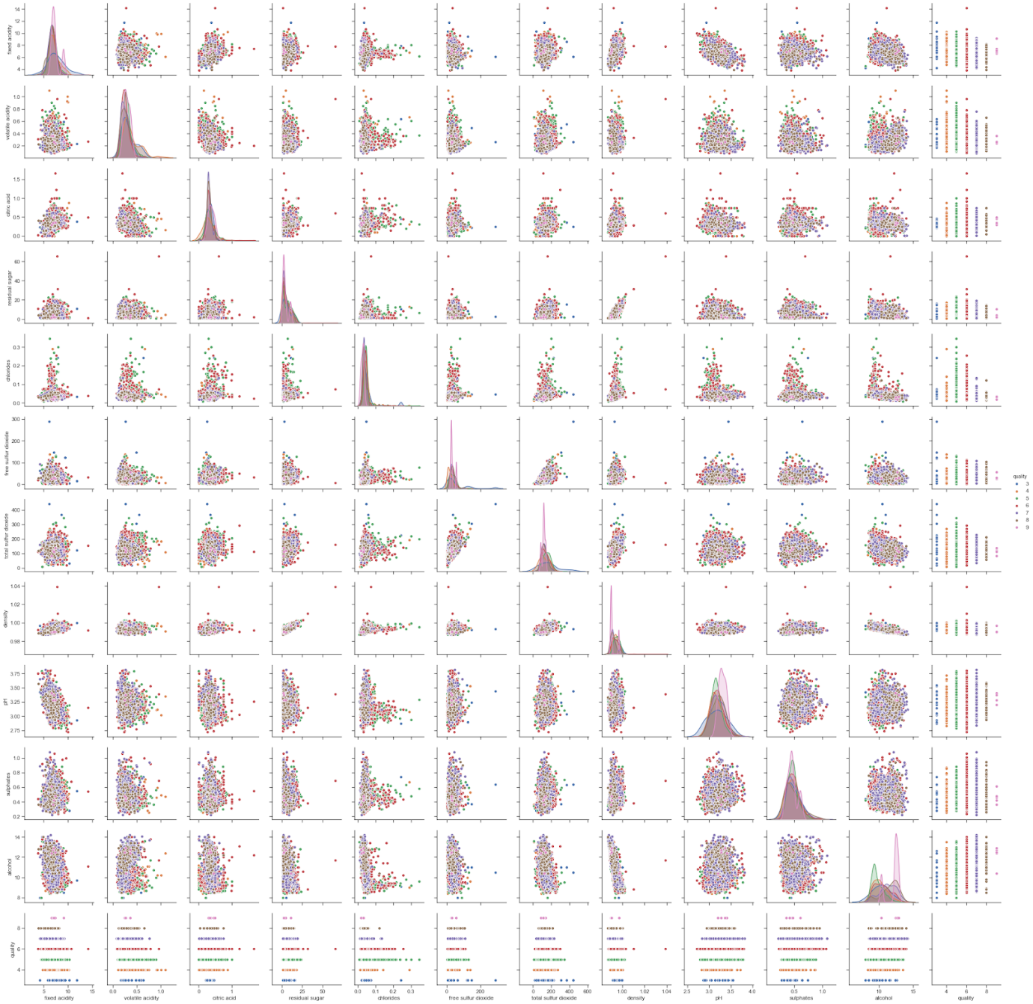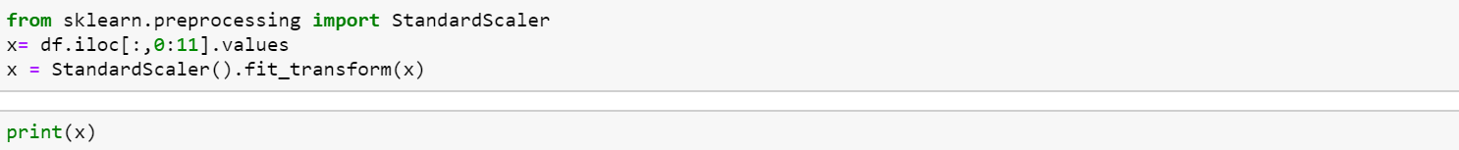

Using hierarchical clustering, we can choose the number of clusters. From the dataset we found that the quality of the wine ranges from 3 to 9, forming 7 clusters. By generating dendrogram to visualize the data, we see that the max distance is about 50 to separate into 7 clusters in order simulate similar results as per the original dataset. Using the bottom down approach, to have a more general view of the clusters, the data can be further clustered into 5 clusters with max distance of 60.

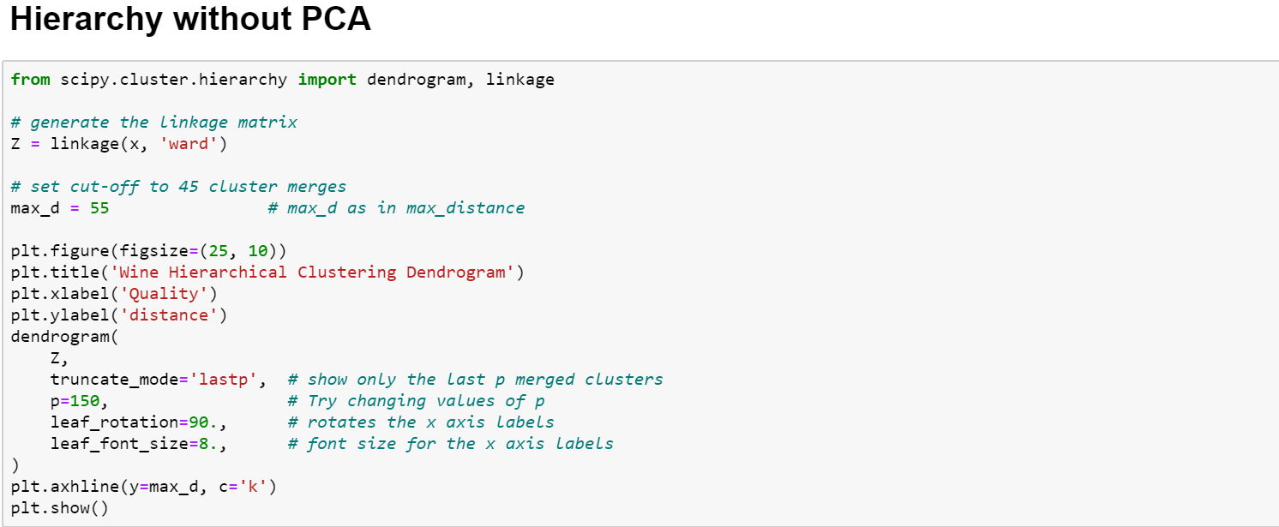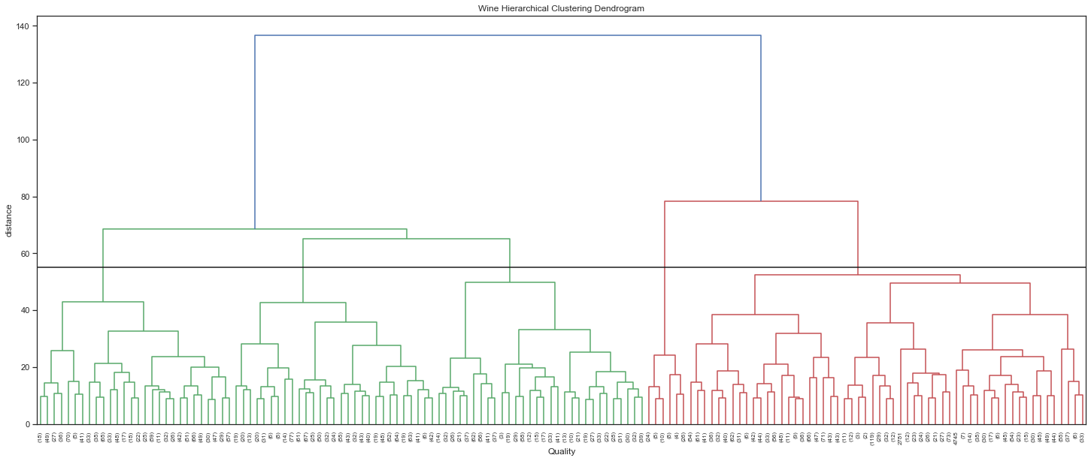



From the clustering scatter plot, we can see that the clustering did not seem very efficient. Different clusters are messed with each other and we can hardly differentiate them by looking.

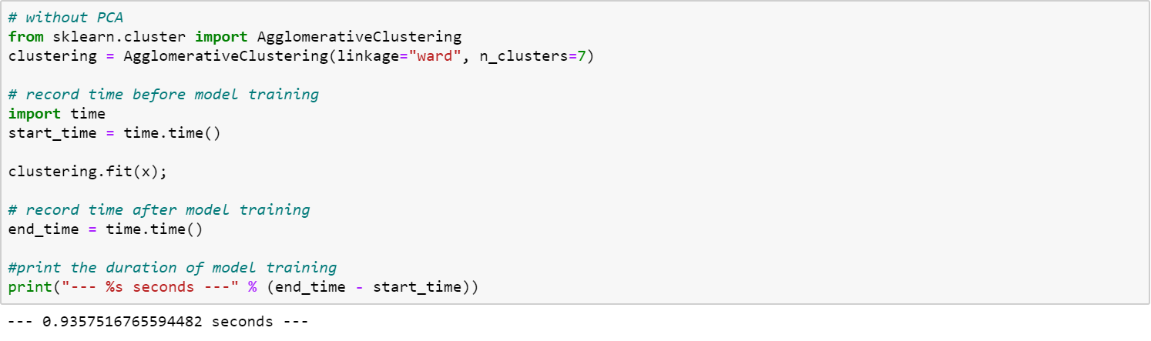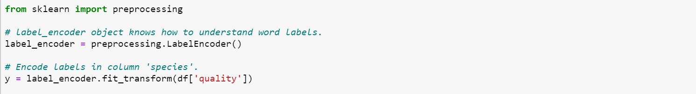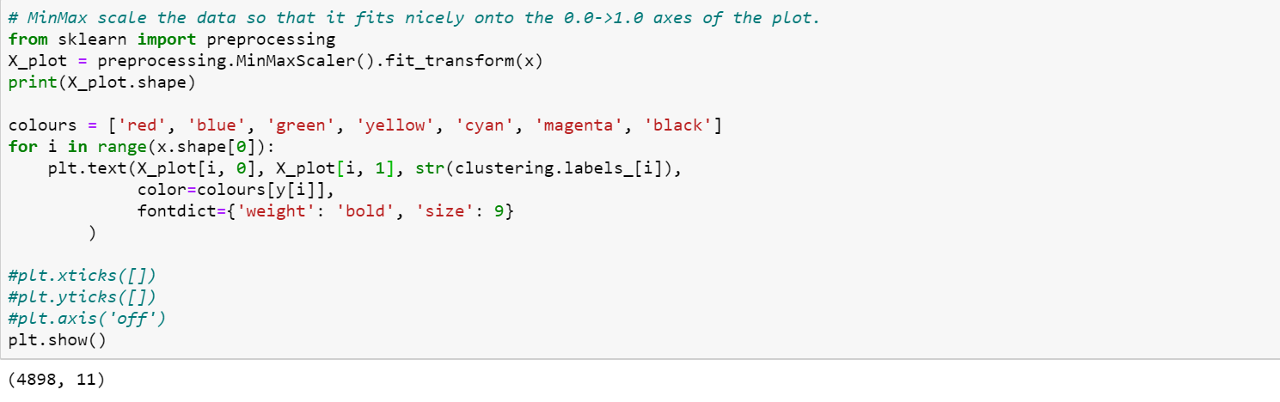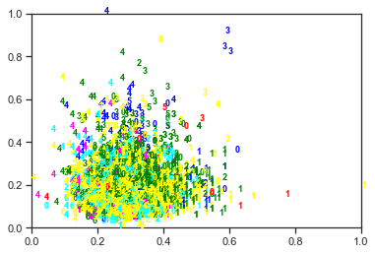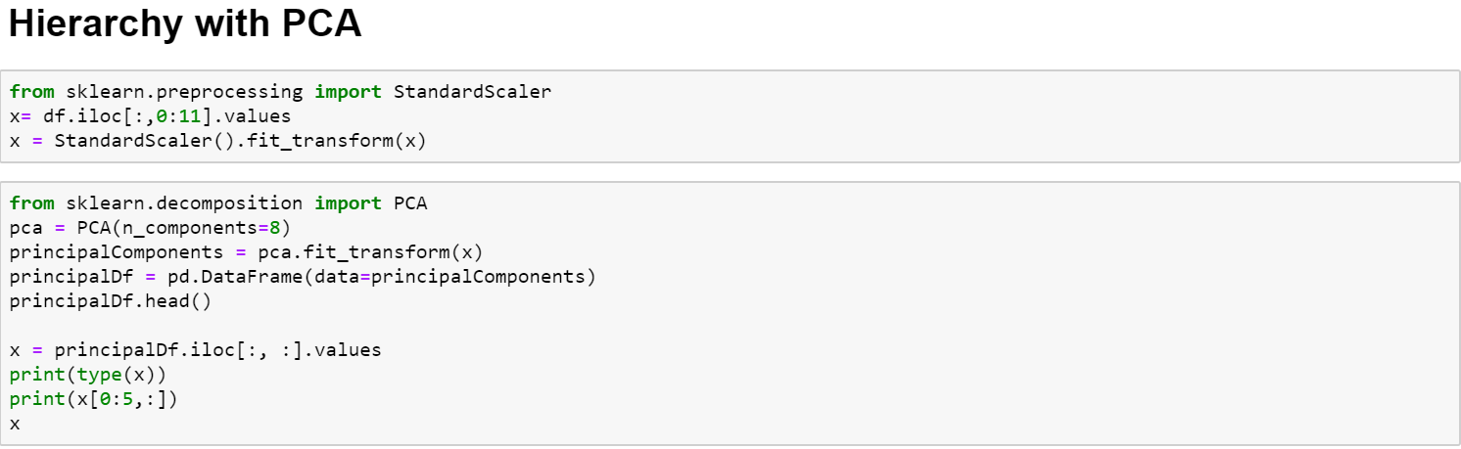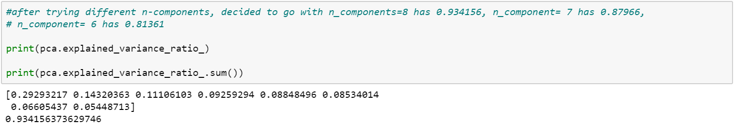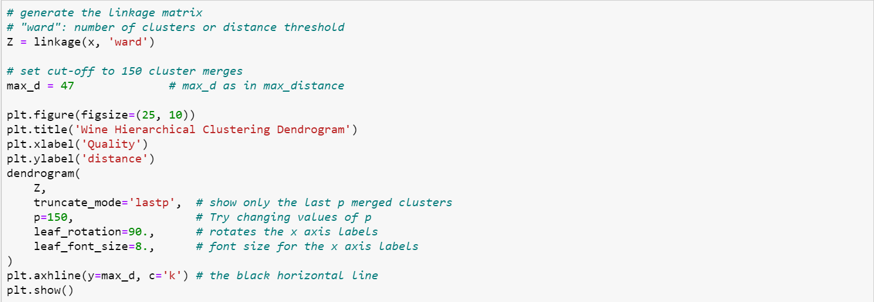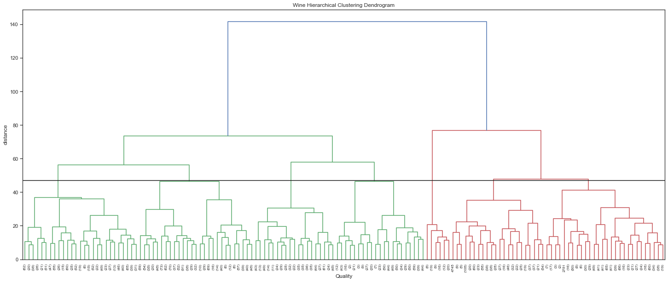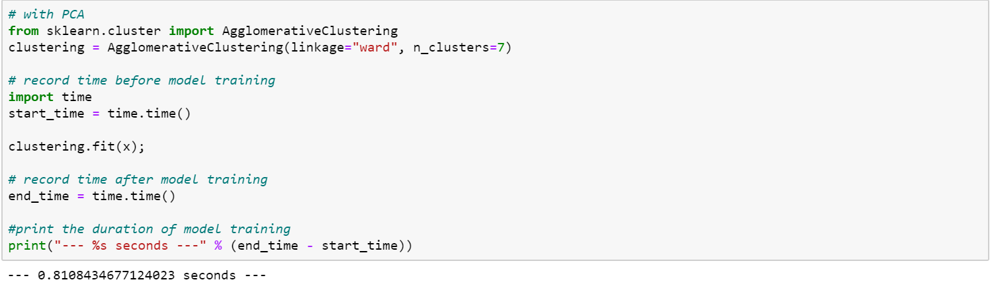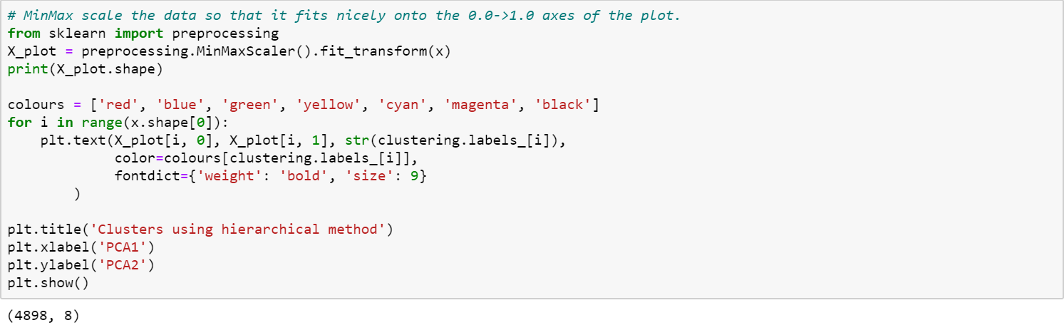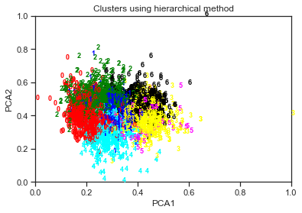

### Impact of data engineering & feature engineering

Using PCA to reduce the dimensions of the data. Trying different n-components. Using n_component of 6 has a variance ratio of 0.81361, n_component of 7 has a variance ratio of 0.87966 and n_component of 8 has a variance ratio of 0.934156.  Wanting to retain more than 90 % of the information during the process, we decided to use 8 components with the variance ratio of 0.934156.

After applying PCA, the scatter plot using PCA1 and PCA 2 shows more distinct clusters and we can easily differentiate 6 clusters from the plot. Reducing the number of clusters might be better to represent the data instead of basing on quality and create 7 clusters.

By using PCA, it combines the original features of the data into a principal component while maintaining maximal variance of the date. As the number of features are being reduced, the dimension of the when training the data is reduced, which can help in reducing the time required to train the model. The time taken to train the model with the help of PCA reduced from 1.0895 to 0.9250 Seconds.

### Other observations

There are some advantages of using hierarchical clustering it is easier to visualize the number of clusters through looking at the dendrogram. Unlike K means where the centroid of the K means is random that will produce different results when run, hierarchical clustering is deterministic and will always produce the same result.

Taking into the consideration of dataset, we chose using ward linkages instead of single or average and complete linkages as through the visualization of the data. The data do not have distinct clusters and noise in the dataset. The more effective linkage is ward for noisy data.

Compare with original data

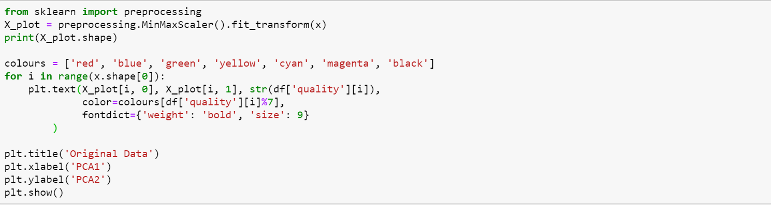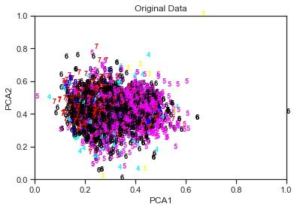

Meanwhile we also plotted the scatter plot for original labels. Can see that using PCA1 and PCA2 as axis, the quality of wine did not actually fall into visible clusters. This essentially means that the clusters produced by our model, is not really reflecting the ‘quality’ attributes of the wines. Maybe it is reflecting something else, for instance, taste. And this can only be further investigated by the wine experts, maybe they can benefit from this clustering results by getting some unexpected discovery.

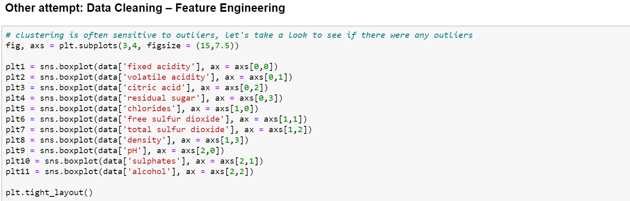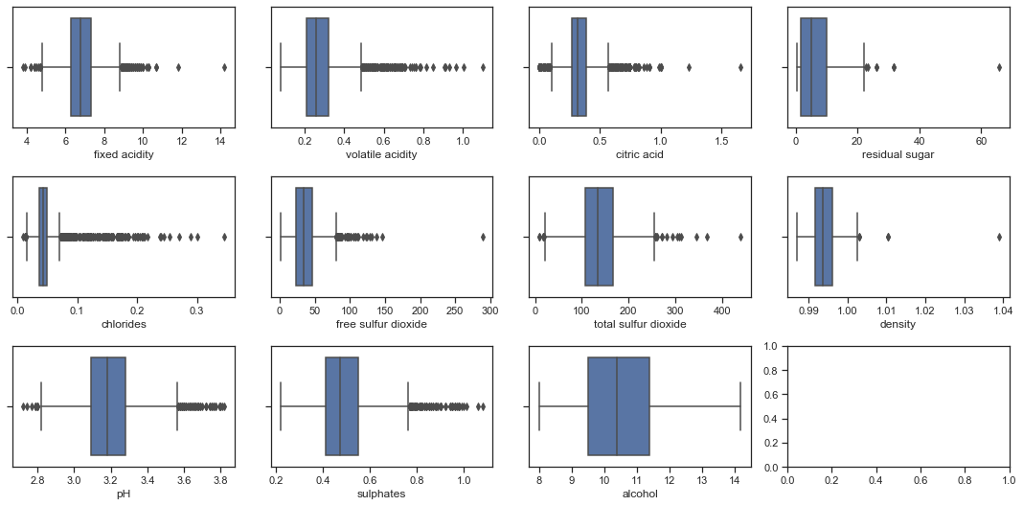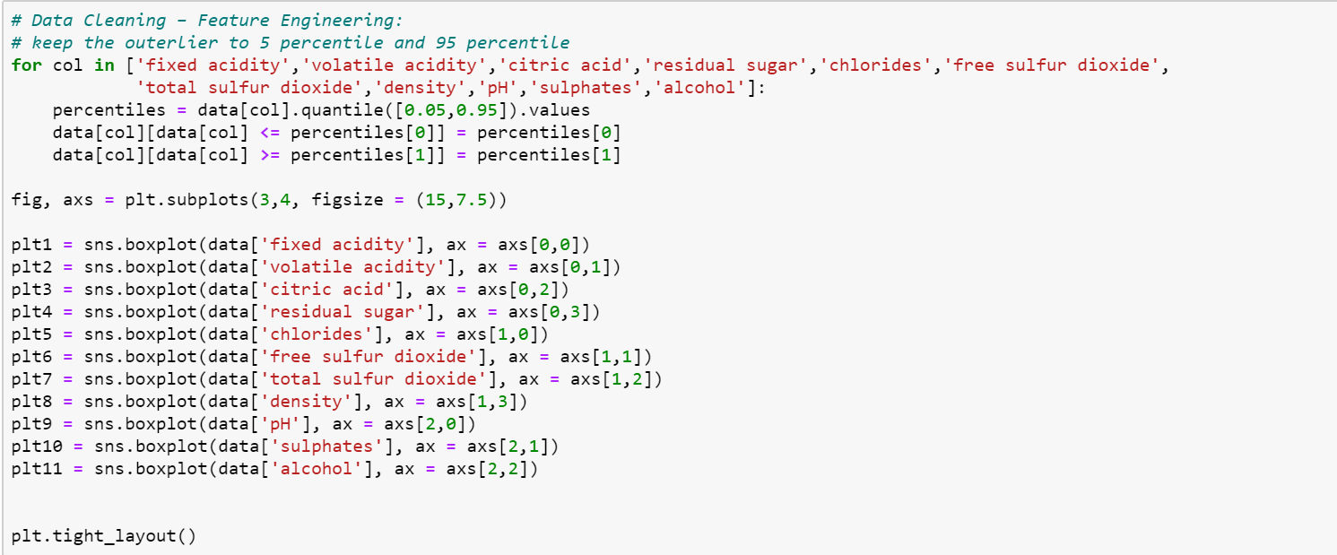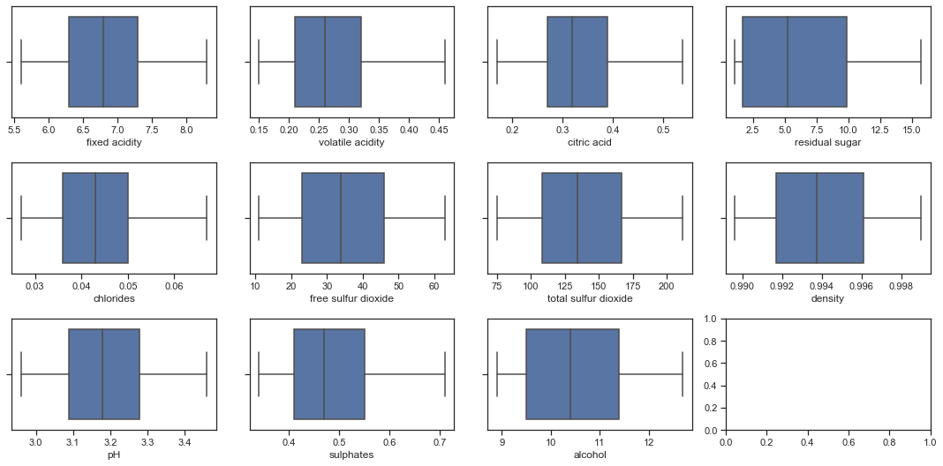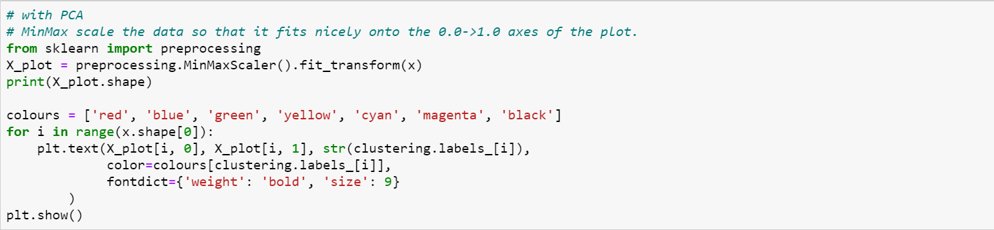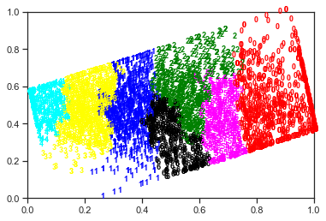

## c) DBSCAN (with & without PCA)

### Duration of training

The duration of training without PCA is 0.1093s.

The duration of training with PCA is 0.1406s.

### Sharing of the process

Data Cleaning and preparation

The dataset has no null value. Since we took ‘quality’ as our classification benchmark, we categorize it, so it can be better comparison with our DBSCAN clustering result.

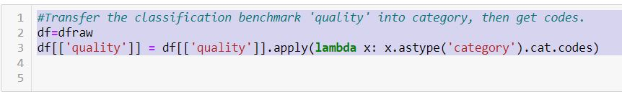

We plot the histogram to see how it distributes.

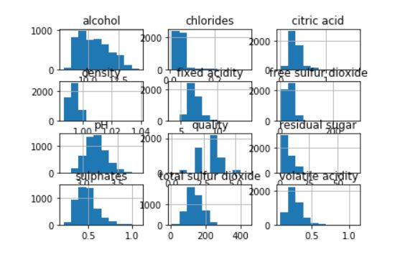

It looks like many columns are not in normalized distribution. So, we tried removing those data that z score within 3, which we think might be outliners.

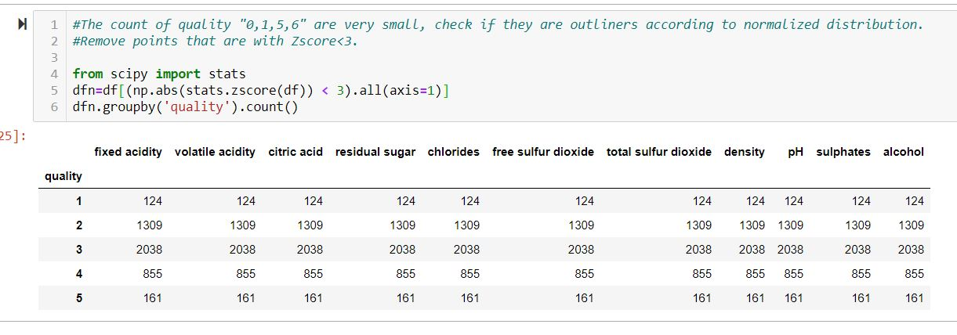

After normalization, all data from quality “0 and 6” which contains 411 data were removed. There might be a better way to deal with these data, but we don’t have much time and resource, we only go with this 5 classes dataset with 4450 data points in this DBSCAN part of report. The challenge in DBSCAN clustering lies in finding the correct eps and MinPts. Trying several methods to calculate the eps and MinPts.

Since the DBSCAN is based on the point density within a given radius circle. We will use “NearestNeighbors” to get the distance of each points to their nearest neighbors first, sort the distance, then choose the distance that can covers the most of the data points as the eps for the DBSCAN clustering.



Plot the distance we got from NearestNeighbors(), we can find the curvature point of the distance as below. From it, we can see total 4450 points out of total 4487 have the distance less than 6, which can be a reasonable start for our eps.

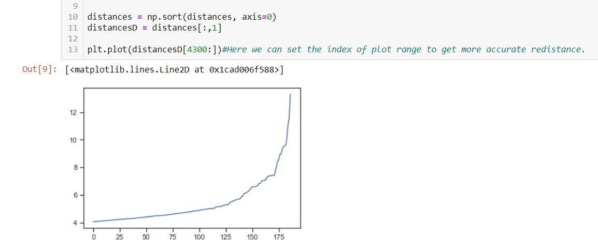

Later we discovered the eps value is critical to the outliner decision. Especially in this dataset case, most of points crowed in one area, basically, we can assume those points whose nearest neighbor distance is bigger than  “eps”, will be considered as outliners by DBSCAN. Then we need estimation of MinPts. This is a bit of tricky, but we luckily discovered there exists an function “query_radius()” from “KDTree” can return the neighbor count of a given radius. We use this function to get neighbor counts of each points within the radius that we set from last step.

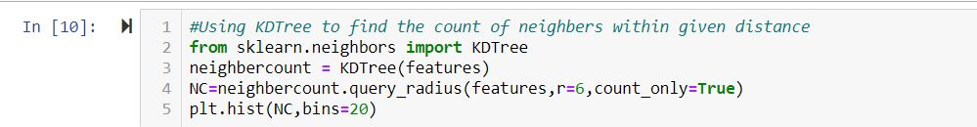

Then we plot our finding.

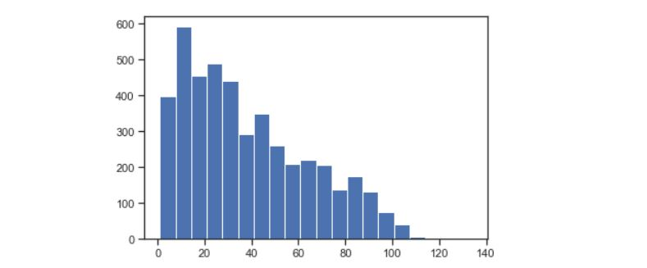

This is the interesting part. Usually the larger neighbor count will have less datapoint. But according to the theory of DBSCAN, if dataset has characteristic groups and borders, we should be able to see one or a few of turning points in neighbor counts, after which the member points start to increase. I believe that turning point could be our estimation of “MinPts”.

From the above plot, we can hardly tell there is such a ‘turning point’ neighbor count. This might be another evidence that this dataset might not be properly clustered by DBSCAN. Anyway, we pick the neighbor account 6 to make a try. (The N account bigger than 6 started to increase sharply).

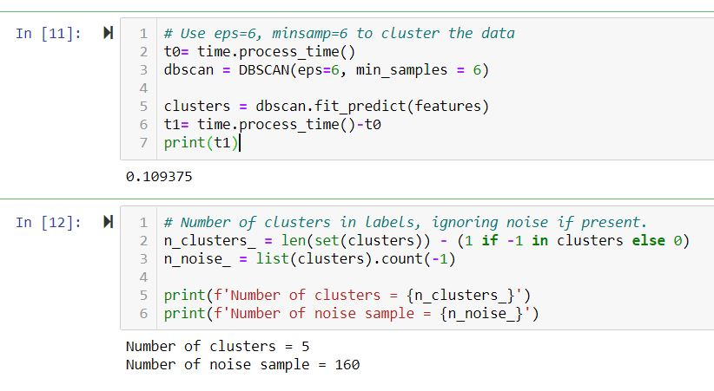

The clustering takes 0.1093s, outcome is 5 clusters and 160 outliners. But when we check the distribution of these 5 clusters:

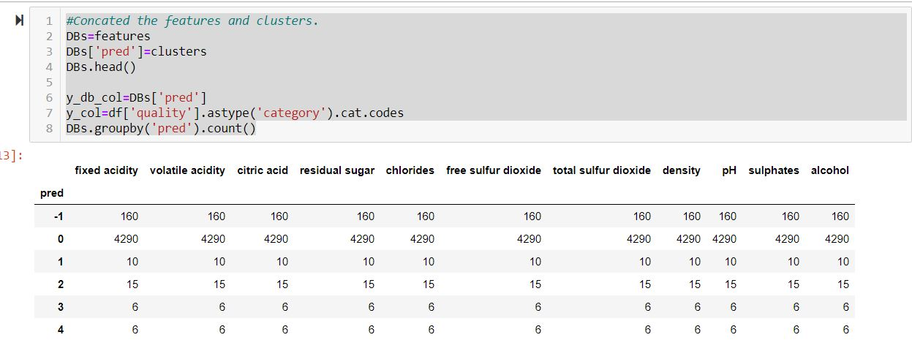

The DBSCAN consider 4290 out of 4487 points as 1 group, and the rest 4 groups contains only 37 members. This is not a classification as our bench mark ‘quality’. No need to do further accuracy validation. Then we tried many different eps and MinPts, the outcomes are similar.

Impact of data engineering & feature engineering We do PCA as feature abstraction. We plot the correlation to have an image of how features correlates to each other.

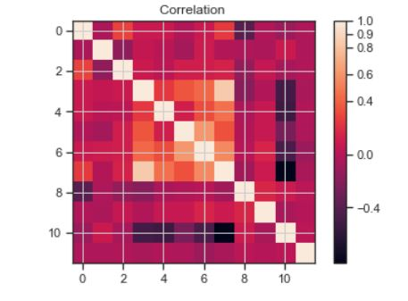

From the correlation plot, we can see features(1vs9), ([4,5,7,8]vs11) has strong correlations with each other. In principle, PCA may extract one feature to stands for 4,5,7,8. This dataset should have good result from PCA treatment.

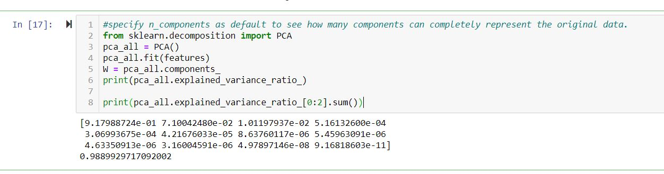

The PCA extracted 12 features, in which the first 2 can represent 98.89% variance. Then we cluster the 2 Principle components (with eps=6, MinPts=6)

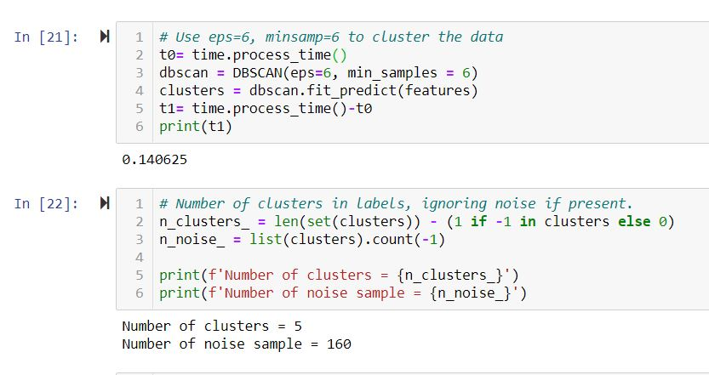

The DBSCAN found 5 clusters and 160 outliners. The same with dataset of 11 features. Even the distribution of 5 cluster members is the same.

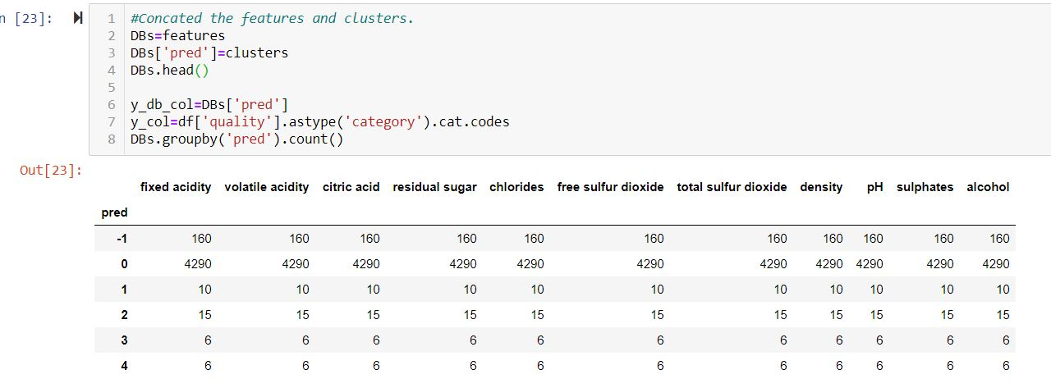

### Impact of data engineering & feature engineering

### Other observations

Interesting observation was found that the meaning of ‘turning point’ neighbor count, after we retrieved the neighbor count with given radius. Sometimes, the histogram will show multiple valley neighbor count.

This might be because the groups in a dataset have different “eps&MinPts” borders. We need further data process to do multiple times of DBSCAN with different “eps and MinPts” to separate these clusters.

### Conclusion

The clusters created using DBSCAN method did not cluster based on wine quality when using the chemical content as it features. As most of the wine chemical contents are highly similar. The points crowed in a dense area that cannot be separated by DBSCAN. Through the process, we discovered a useful method to estimate the initial “eps and MinPts” for DBSCAN, which is using NearestNeighbor to get and plot all distance to its NearestNeighbor of each point to observe the curvature as estimated eps. Then use query_radius() from KDTree to get to neighbor count of each points within given radius from first step. Tested the PCA on this white wine dataset. It has pretty good performance that 2 components can represent over 98% variance out of 11 features.

The reason why we failed to cluster the data into quality might because the “eps and MinPts” of each group are different. We may need multiple “eps and MinPts” to do multiple times of DBSCAN to cluster out different ‘quality’ respectively.

### Conclusion (model that yields the best outcome)

Initially we wanted to used the different clustering method to predict the wine quality, clustering them into 7 clusters as per the initial data. After training the models DBSCAN, K-Means and Agglomerative (Hierarchical) clustering. Using DBSCAN we are unable to get distinct clusters which are linked to wine quality. By using the elbow method and it is recommended to cluster the data into 2 clusters, therefore using K-means if we cluster the data into 7 clusters, the model will not be accurate. The model that gives the best outcome is the Hierarchical clustering. With Hierarchical clustering we can choose the number of clusters and attempt to simulate similar results from the original data.

# Part 3: Attempting Neural Network

### Duration of training

418.2s for original 11 features feed.

406.0s for 2 principle components features feed.

### Sharing of the process

Import the library and prepare data.  We categorize the ‘quality’ as the target outcome we want to classify and predict. Split the dataset by 3:1, take 75% part for training, the rest for validation.

Firstly, we define the neural network model. Take care the ‘input_shape()’ parameter of input layer need be consist with the number of our input features. And the parameter of Dense() of the output layer need be consist with the number of our output features. Try to let the model learn more complicated logic, we added 2 hidden layers, but the outcome is not much different from 1 hidden layer.

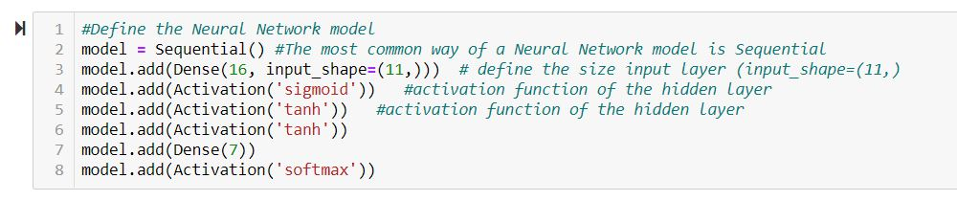

Define the early stopping. We like it early stop if accuracy meet the max value for 10 times.



Then compile the model.

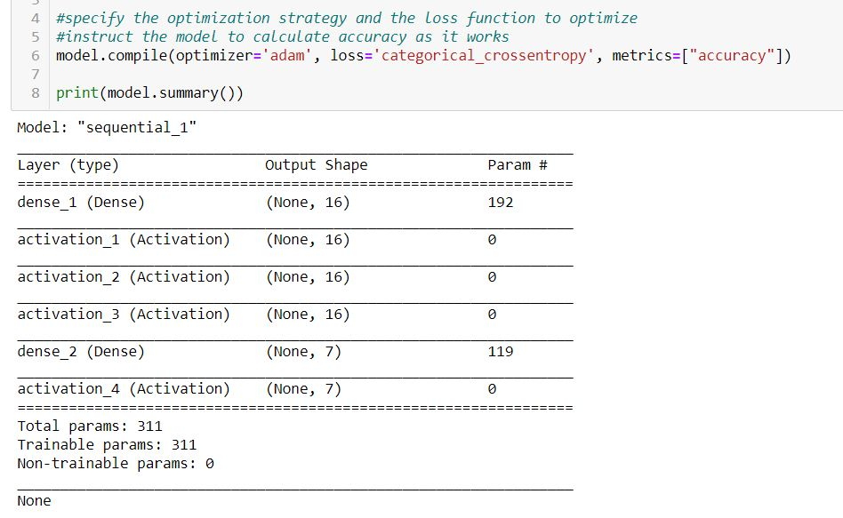

One hot encoding the output.

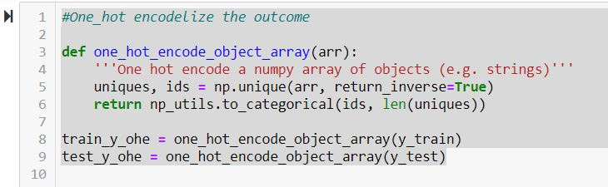

Train the model, set epochs to 50, batch size as 1, mark the training time.

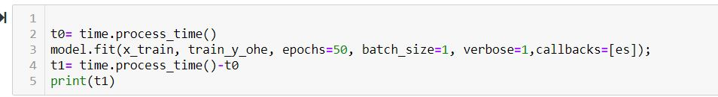

The outcome accuracy is 50.9% with 418second training duration.



### Impact of data engineering & feature engineering

Do PCA on the dataset, use 2 principle components (represent 98% variance) to train neural model.

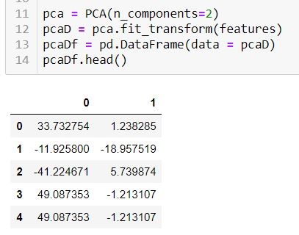

Define Neural Network Model2, and train it.

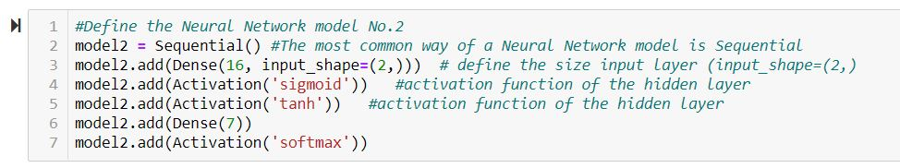



The result accuracy is 46.58% with training time of 382s.

### Other observations

Tried add one more hidden layer and increase the Dense number. The result doesn’t show much improvement. We also tried Random Forest model, the accuracy is similar.

### Conclusion

The Neural Networking model got slightly better accuracy result than other models, but it takes far much longer training time. The PCA helps a bit of training time, but not obviously. To achieve better prediction of this dataset, need rework the dataset from the start, such as binning the likely quality samples (quality 1,2,3) into larger new column (Newquality A); or we can screen out large amount samples of quality 4,5,6 into new set of data to analysis separately.